QUICKLOAD: A RELIABLE PLATFORM FOR INTEGRATING GOODS TRANSPORT WITH SMART VEHICLE ALLOCATION

CAPSTONE PROJECT REPORT

Submitted by
Boppana Rohith – 99220041454 Anisetty Sai Prajwin – 99220041438 Bachula Yaswanth Babu – 99220041445 Yerla Vinayasree – 99220041423

in partial fulfillment for the award of the degree of
BACHELOR OF TECHNOLOGY
IN

COMPUTER SCIENCE AND ENGINEERING


SCHOOL OF COMPUTING COMPUTER SCIENCE AND ENGINEERING KALASALINGAM ACADEMY OF RESEARCH
AND EDUCATION KRISHNANKOIL 626 126
April 2026

DECLARATION

We affirm that the project work titled “QUICKLOAD: A RELIABLE PLATFORM FOR
INTEGRATING GOODS TRANSPORT WITH SMART VEHICLE ALLOCATION”
being submitted in partial fulfillment for the award of the degree of Bachelor of Technology in Computer Science and Engineering is the original work carried out by us. It has not formed part of any other project work submitted for the award of any degree or diploma, either in this or any other University.
Boppana Rohith 99220041454
Anisetty Sai Prajwin

99220041438

Bachula Yaswanth Babu

99220041445

Yerla Vinayasree 99220041423
This is to certify that the above statement made by the candidate is correct to the best of my knowledge.
Date:

Signature of supervisor Mr. N. R. Sathis Kumar Assistant Professor
Department of Computer Science and Engineering



BONAFIDE CERTIFICATE

Certified that this project report “QUICKLOAD: A RELIABLE PLATFORM FOR INTEGRATING GOODS TRANSPORT WITH SMART VEHICLE ALLOCATION” is the bonafide work of “BOPPANA ROHITH (99220041454), ANISETTY SAI PRAJWIN (99220041438), BACHULA YASWANTH BABU (99220041445), YERLA VINAYASREE
(99220041423),” who carried out the project work under my supervision.

Mr. N. R. Sathis Kumar Dr. R. Raja Subramanian
SUPERVISOR HEAD OF THE DEPARTMENT
Assistant Professor Associate Professor
Computer Science and Engineering Computer Science and Engineering

Kalasalingam Academy of Research and Education
Kalasalingam Academy of Research and Education

Krishnankoil 626126 Krishnankoil 626126
Virudhunagar District. Virudhunagar District.

Submitted for the Project Viva-voce examination held on

Internal Examiner External Examiner

ACKNOWLEDGEMENT

We would like to begin by expressing our heartfelt gratitude to the Supreme Power for the immense grace that enabled us to complete this project.
We are deeply grateful to the late "Kalvivallal" Thiru T. Kalasalingam, Chairman of the Kalasalingam Group of Institutions, and to "Illayavallal" Dr. K. Sridharan, Chancellor, as well as Dr. S. Shasi Anand, Vice President, who has been a guiding light in all our university’s endeavours.
Our sincere thanks go to our Vice Chancellor, Dr. S. Narayanan, for his inspiring leadership, guidance, and for instilling in us the strength and enthusiasm to work towards our goals.
We would like to express our sincere appreciation to Dr. P. Deepalakshmi, Professor & Dean-(SoC), Director Accreditation & Ranking, for her valuable guidance. Our heartfelt gratitude also goes to our esteemed Head of Department, Dr. R. Raja Subramanian, whose unwavering support has been crucial to the successful advancement of our project.
We are especially thankful to our Project Supervisor, Mr. N. R. Sathis Kumar, for his patience, motivation, enthusiasm, and vast knowledge, which greatly supported us throughout this work.
Our sincere gratitude also goes to Dr. T. Manikumar and Mr. N. R. Sathis Kumar Overall Project Coordinators, for their constant encouragement and support in completing this Capstone Project.
Finally, we would like to thank our parents, faculty, non-teaching staff, and friends for their unwavering moral support throughout this journey.



SCHOOL OF COMPUTING COMPUTER SCIENCE AND ENGINEERING
PROJECT SUMMARY

Project Title | QUICKLOAD: A RELIABLE PLATFORM FOR INTEGRATING GOODS TRANSPORT WITH SMART VEHICLE ALLOCATION
Project Team Members (Name with Register No) | Boppana Rohith (99220041454), Anisetty Sai Prajwin (99220041438), Bachula Yaswanth Babu (99220041445), Yerla Vinayasree (99220041423)
Guide Name/Designation | Mr. N. R. Sathis Kumar/ Assistant Professor
Program Concentration Area | Web Application Development, Intelligent Transportation Systems (ITS), Database Management Systems, Applied Artificial Intelligence
Technical Requirements | Python, HTML, CSS, Javascript and SQL
Engineering standards and realistic constraints in these areas
Area | Codes & Standards / Realistic Constraints | Tick ✓
Economic | Uses open-source technologies to minimize development and operational costs. | ✓
Environmental | Reduces fuel consumption and emissions through optimized vehicle allocation. | ✓
Social | Improves accessibility and fairness by directly connecting users and drivers. | ✓
Ethical | Ensures data privacy, transparency in pricing, and secure user authentication. | ✓
Health and Safety | Promotes verified driver onboarding and secure trip management. | ✓
Manufacturability | Implemented using widely available software tools and platforms. | ✓
Sustainability | Designed for long-term scalability and efficient resource utilization. | ✓

ABSTRACT
The rapid expansion of urbanization, e-commerce, and small-scale commercial activities has significantly increased the demand for efficient and reliable goods transportation services. However, the existing goods transport ecosystem is largely unorganized and dependent on intermediaries, leading to inefficiencies such as delayed vehicle allocation, lack of pricing transparency, poor resource utilization, and reduced earnings for independent vehicle owners. Customers often face difficulties in identifying suitable vehicles within a short time, while vehicle owners experience prolonged idle periods due to inefficient demand–supply matching.
To address these challenges, this project proposes QuickLoad, a reliable and intelligent web- based platform that integrates goods transportation with smart vehicle allocation and AI-driven dynamic pricing. The system directly connects customers with nearby independent goods vehicle owners, thereby eliminating middlemen and ensuring faster, more affordable, and transparent bookings. QuickLoad employs geospatial intelligence for accurate distance calculation and integrates a Geo-Dynamic Multi-Factor Logistics Engine that determines real- time pricing based on multiple contextual factors including travel distance, vehicle type, payload weight, and time-based demand fluctuations.
The proposed system utilizes a modular architecture that enables scalable and low-latency operations while ensuring fairness for both customers and drivers. By incorporating dynamic demand modeling and vehicle-specific operational cost analysis, the platform generates trustworthy and data-driven price estimates without manual negotiation. The system supports multiple vehicle categories such as three-wheelers, mini-trucks, pickup vehicles, and heavy trucks, making it suitable for a wide range of local and intra-city logistics requirements.

TABLE OF CONTENTS

TITLE |  | PAGE NO.
ABSTRACT |  | vi
LIST OF TABLES |  | x
LIST OF FIGURES |  | xi-xii
LIST OF ACADEMIC REFERENCE COURSES |  | xiii
CHAPTER I | INTRODUCTION | 1-4
1.1 | Background and Motivation
1.2 | Problem Statement
1.3 | Objectives of the Project
1.4 | Scope of the Project
1.5 | Methodology Overview
1.6 | Organization of the Report
CHAPTER II | LITERATURE REVIEW | 5-9
2.1 | Overview of Related Work | 5-7
2.2 | Review of Similar Projects or Research Papers | 7-8
2.3 | Summary and Gap Identification | 8-9
CHAPTER III | SYSTEM ANALYSIS | 10-17
3.1 | Requirements Gathering | 10-11
3.2 | Functional Requirements | 11-12
3.3 | Non-Functional Requirements | 12-13
3.4 | Feasibility Study  - Technical Feasibility  - Operational Feasibility  - Economic Feasibility | 13-16
3.5 | Risk Analysis | 16-17
CHAPTER IV | SYSTEM DESIGN | 18-29
4.1 | Overall System Architecture | 18-19
4.2 | Module Design | 19
4.2.1 | User Management & Authentication Module | 19-20
4.2.2 | Driver & Vehicle Management Module | 20

4.2.3 | Booking & Trip Management Module | 20
4.2.4 | Map & Route Visualization Module (Leaflet) | 20-21
4.2.5 | AI-Based Pricing & Allocation Module | 21
4.2.6 | Admin Dashboard & Monitoring Module | 21-22
4.3 | Database Design | 22
4.3.1 | ER Diagram | 22-24
4.3.2 | Database Schema | 24-26
4.4 | User Interface Design | 26-28
4.4.1 | User Flow Diagrams | 29
CHAPTER V | IMPLEMENTATION | 30-34
5.1 | Technology Stack | 30
5.1.1 | Programming Languages and Tools | 30-31
5.2 | Implementation of Modules | 31
5.2.1 | User Authentication and Management Module | 31
5.2.2 | Driver Registration and Vehicle Management Module | 31-32
5.2.3 | Booking and Trip Management Module | 32
5.2.4 | Map and Route Visualization Module (Leaflet) | 32-33
5.2.5 | AI-Based Pricing and Allocation Module | 33
5.2.6 | Admin Dashboard and Monitoring Module | 33
5.3 | Integration of Modules | 33-34
CHAPTER VI | TESTING | 35-39
6.1 | Testing Methodology | 35
6.1.1 | Unit Testing | 35-36
6.1.2 | Integration Testing | 36-37
6.1.3 | System Testing | 37

6.1.4 | User Acceptance Testing (UAT) |  |  | 38
6.2 | Test Cases and Results |  |  | 38-39
6.3 | Bug Tracking and Resolution |  |  | 39
CHAPTER VII | RESULTS AND DISCUSSION |  |  | 40-53
7.1 | System Output Screenshots |  |  | 40-50
7.2 | Evaluation Metrics |  |  | 50-51
7.3 | Comparison with Existing Systems |  |  | 51-52
7.4 | Challenges Faced |  |  | 52
7.5 | Solutions and Improvements |  |  | 52-53
CHAPTER VIII | CONCLUSION & FUTURE SCOPE |  |  | 54
REFERENCES : List of books, articles, research papers, and other resources used |  |  |  | 55
PUBLICATION
CERTIFICATI ONS
PLAGIARISM REPORT

LIST OF TABLES

TABLES | DETAILS | PAGE NO.
Table 4.1 | Users Table | 24
Table 4.2 | Drivers Table | 24-25
Table 4.3 | Vehicles Table | 25
Table 4.4 | Trips Table | 25
Table 4.5 | OTP Verification Table | 25-26
Table 4.6 | Admin Logs Table | 26
Table 6.1 | Test Cases and Results | 38-39
Table 7.1 | Comparison with Existing Systems | 51-52

LIST OF FIGURES

FIGURES | DETAILS | PAGE NO.
Figure 4.1 | System Architecture | 19
Figure 4.2 | ER Diagram | 23
Figure 4.3 | Landing Page | 27
Figure 4.4 | Customer SignUp Interface | 27
Figure 4.5 | OTP Verification | 28
Figure 4.6 | Customer Login Interface | 28
Figure 4.7 | User Flow Diagram | 29
Figure 7.1 | Customer Home Page | 40
Figure 7.2 | Customer Vehicle Booking Form | 41
Figure 7.3 | Vehicle Selection with Route Map | 41
Figure 7.4 | Customer Profile | 42
Figure 7.5 | Customer Bookings | 42
Figure 7.6 | Customer Tax Invoice | 43
Figure 7.7 | Driver Registration Page | 43
Figure 7.8 | Driver Login Interface | 44
Figure 7.9 | Driver Dashboard | 44
Figure 7.10 | Driver Trip Requests | 45
Figure 7.11 | Driver Trips Page | 45
Figure 7.12 | Manage Vehicles (Driver) | 46
Figure 7.13 | Driver Earnings | 46
Figure 7.14 | Driver Profile | 47
Figure 7.15 | Admin Login Interface | 47

Figure 7.16 | Admin Dashboard | 48
Figure 7.17 | Driver Applications (Admin) | 48
Figure 7.18 | Manage Drivers and Vehicles | 49
Figure 7.19 | Manage Customers | 49
Figure 7.20 | Manage Trips | 50
Figure 7.21 | Manage Developers | 50

LIST OF ACADEMIC REFERENCE COURSES

S. NO. | COURSE CODE | COURSE NAME
1 | 211CSE1402 | Python Programming
2 | 212CSE2304 | Machine Learning
3 | 212CSE2305 | Database Management Systems
4 | 212CSE2303 | Software Engineering
5 | 212CSE3305 | Secured Computing

CHAPTER – I INTRODUCTION

Background and Motivation
In recent years, the logistics and transportation sector has undergone significant transformation due to rapid urbanization, the growth of e-commerce, and the increasing reliance of individuals and small businesses on efficient goods movement services. In developing economies such as India, goods transportation plays a crucial role in supporting trade, manufacturing, retail distribution, and daily commercial activities. Despite this importance, a large segment of the goods transport ecosystem remains unorganized and inefficient.
Traditionally, customers seeking to transport goods depend on local agents, brokers, or middlemen to identify suitable vehicles. This manual and fragmented approach often results in excessive waiting time, lack of transparency in pricing, inconsistent service quality, and unfair revenue distribution. Vehicle owners, especially independent drivers and small fleet operators, frequently face idle time and uncertainty in securing trips, which negatively impacts their earnings and operational efficiency.
Although digital platforms have successfully disrupted passenger transportation services, similar advancements in the goods transportation domain are still limited. Existing logistics platforms primarily cater to large enterprises, rely on centralized architectures, or involve complex pricing mechanisms that are not transparent to end users. Furthermore, most current systems consider only basic parameters such as proximity and availability, while ignoring critical contextual factors like load weight, vehicle capacity, route complexity, and time-based demand fluctuations.
The motivation behind the QuickLoad project arises from the need to bridge this gap by introducing a reliable, intelligent, and user-centric platform for goods transportation. QuickLoad leverages modern web technologies, geospatial intelligence, and AI-driven pricing mechanisms to directly connect customers with nearby vehicle owners. By eliminating intermediaries and automating decision-making, the platform aims to ensure fairness, efficiency, and transparency while enhancing overall logistics performance.

Problem Statement

Despite technological progress in transportation services, the goods logistics sector continues to face several persistent challenges:
    - Customers struggle to identify appropriate vehicles that match their specific load requirements within a short time.
    - Vehicle owners experience prolonged idle periods due to lack of demand visibility and inefficient job allocation.
    - Pricing mechanisms are opaque and heavily influenced by intermediaries, resulting in higher costs for customers and reduced profits for drivers.
    - Existing platforms largely rely on static or location-based matching algorithms, without incorporating factors such as payload weight, vehicle economics, or temporal demand.
    - Centralized systems introduce latency, scalability limitations, and potential privacy concerns.
These issues highlight the absence of a unified, intelligent, and scalable solution that can perform real-time matching and pricing while ensuring fairness, transparency, and efficient utilization of transport resources.

Objectives of the Project
The primary objective of the QuickLoad project is to design and implement a smart logistics platform that improves goods transportation efficiency through intelligent vehicle allocation and dynamic pricing. The specific objectives are as follows:
    - To develop a web-based platform that enables direct interaction between customers and goods vehicle owners.
    - To eliminate middlemen from the booking process, thereby reducing costs and delays.

    - To implement a smart vehicle allocation mechanism based on distance, vehicle type, load capacity, and availability.
    - To design and integrate an AI-driven dynamic pricing engine that considers multiple real-world factors such as geospatial distance, payload weight, vehicle operational costs, and time-based demand.
    - To ensure transparency and fairness in pricing for both customers and vehicle owners.

    - To provide a scalable, secure, and user-friendly system suitable for real-time logistics operations.

Scope of the Project
The scope of the QuickLoad project focuses on providing an efficient solution for local and intra-city goods transportation. The key aspects covered under the scope include:
    - Development of a full-stack web application for booking goods transportation services.

    - Support for multiple vehicle categories including three-wheelers, mini-trucks, pickup vehicles, and heavy trucks.
    - Accurate distance computation using geospatial techniques for reliable fare estimation.

    - Implementation of a geo-dynamic multi-factor pricing algorithm that accounts for distance, load weight, vehicle type, and time-based demand.
    - User modules for customers and vehicle owners with secure authentication and session management.
The project does not include international logistics operations, warehouse management systems, or large-scale supply chain optimization. Its primary focus is on last-mile and short- to-medium distance goods transportation.

Methodology Overview
The development of the QuickLoad platform follows a structured and systematic software engineering methodology to ensure reliability and quality. The major phases are outlined below:
- Requirement Analysis – Detailed analysis of user needs, system constraints, and logistics challenges through study of existing systems and problem scenarios.
- System Design – Design of overall architecture, functional modules, data flow, and interaction between system components.
- Algorithm Design – Development of a geo-dynamic multi-factor logistics engine for intelligent pricing and allocation.
- Implementation – Coding of frontend and backend modules using appropriate programming languages, frameworks, and libraries.

- Testing – Comprehensive testing including unit testing, integration testing, and system testing to ensure correctness and robustness.
- Evaluation and Deployment – Performance evaluation and validation of system functionality in real-world scenarios.
This methodology ensures modularity, scalability, and ease of future enhancements.

Organization of the Report
This project report is organized into eight chapters, each addressing a specific aspect of the system development:
    - Chapter I provides an introduction to the project, including background, motivation, problem statement, objectives, scope, and methodology.
    - Chapter II presents a comprehensive literature review of existing logistics systems, intelligent transportation solutions, and related research work.
    - Chapter III focuses on system analysis, detailing requirements, feasibility studies, and risk assessment.
    - Chapter IV describes the system design, including architecture, module design, and database structure.
    - Chapter V explains the implementation details, technology stack, and module integration.
    - Chapter VI discusses testing strategies, test cases, and validation results.

    - Chapter VII analyzes the results, evaluates system performance, and compares the proposed system with existing solutions.
    - Chapter VIII concludes the report and outlines future scope and possible enhancements.

CHAPTER-II

LITERATURE REVIEW

Overview of Related Work
The evolution of goods transportation and logistics systems has been significantly influenced by advancements in digital technologies, including cloud computing, Internet of Things (IoT), artificial intelligence (AI), and intelligent transportation systems (ITS). Over the past decade, researchers and industry practitioners have focused on improving efficiency, scalability, and responsiveness in logistics operations to meet the growing demands of urbanization, e- commerce, and just-in-time delivery models.
Early logistics platforms were primarily centralized and rule-based, relying heavily on manual coordination and static decision-making mechanisms. These systems often suffered from high latency, limited adaptability, and poor scalability, particularly under dynamic and high-demand scenarios. As logistics networks expanded in size and complexity, the limitations of centralized architectures became increasingly evident, prompting research into distributed, data-driven, and intelligent solutions.
Fleet Management Systems (FMS) have been a foundational component of modern logistics. Studies in the Logistics 4.0 paradigm emphasize the transition from traditional fleet tracking to real-time, distributed, and scalable architectures. Researchers have highlighted that integrating real-time data streams from vehicles and infrastructure can significantly enhance decision-making and operational efficiency. However, many of these systems still depend on centralized cloud servers, which introduce communication delays and create single points of failure.
The emergence of Intelligent Transportation Systems (ITS) further advanced logistics research by incorporating traffic monitoring, route optimization, and vehicle-to-infrastructure communication. IoT-enabled ITS solutions enable continuous data collection from sensors, GPS devices, and connected vehicles, facilitating real-time traffic control and congestion management. While these approaches improve situational awareness, their effectiveness is often constrained by cloud dependency and the lack of fine-grained, context-aware decision- making at the edge.

Edge computing has recently gained prominence as a solution to address latency and scalability challenges in cloud-centric systems. By processing data closer to the source, edge-assisted architectures reduce response time and enhance system resilience, particularly in environments with unreliable connectivity. In logistics and transportation, edge computing enables localized decision-making for vehicle allocation, route planning, and demand forecasting. Researchers have demonstrated that distributing computation across edge nodes can significantly reduce booking delays and improve resource utilization.
Another critical research direction involves context-aware systems, which consider multiple real-world factors such as load characteristics, vehicle capacity, traffic conditions, driver reliability, and temporal demand patterns. Unlike traditional location-based matching algorithms, context-aware approaches aim to provide personalized and optimized services by dynamically adapting to changing operational conditions. However, designing efficient context-aware models that scale across large logistics networks remains a challenge.
More recently, federated learning has been explored as a privacy-preserving approach for collaborative model training in distributed transportation systems. By allowing edge nodes to train models locally and share only aggregated updates, federated learning reduces data transfer overhead and protects sensitive user information. Although promising, most existing studies focus on traffic prediction or vehicle clustering rather than real-time service allocation in goods transportation.
Overall, the literature indicates a growing shift toward decentralized, intelligent, and context- aware logistics platforms. Despite notable progress, there remains a gap in integrating edge computing, context-aware matching, and dynamic pricing into a unified, real-time goods transportation system.
Key Points – Overview of Related Work

- Transition from manual and centralized logistics systems to data-driven and intelligent platforms.
- Increasing adoption of Logistics 4.0 principles in fleet management systems.

- Widespread use of IoT and ITS for real-time traffic monitoring and operational visibility.
- Emergence of edge computing to reduce latency and improve system resilience.

- Growing importance of context-aware decision-making in logistics services.

- Introduction of federated learning to enhance privacy and scalability.

Review of Similar Projects or Research Papers
Several research studies have contributed to the development of intelligent and scalable logistics systems. Distributed fleet management architectures proposed in recent studies demonstrate how real-time data processing and decentralization can improve system responsiveness and scalability. These architectures support near real-time monitoring of vehicle status and enable adaptive decision-making, but they often focus primarily on fleet operations rather than end-to-end customer–vehicle matching.
Research on the integration of fleet management and traffic control systems highlights the importance of considering real-time traffic conditions in logistics planning. Studies show that systems ignoring contextual traffic data suffer from inefficiencies such as increased idle time and delayed deliveries. While these works establish the need for integrated traffic awareness, they do not sufficiently address personalized vehicle allocation or pricing transparency for customers.
IoT-enabled logistics systems have been widely studied for their ability to enhance real-time visibility and operational control. Models combining IoT and AI have been proposed for traffic monitoring, congestion control, and emissions prediction in transportation networks. These approaches contribute to sustainability and environmental monitoring; however, they primarily focus on macro-level traffic management rather than micro-level booking and allocation decisions in goods transportation.
Intelligent Transportation Systems for smart cities incorporate technologies such as vehicular ad-hoc networks, virtual traffic lights, and mobility prediction models. These systems improve safety, efficiency, and sustainability in urban transport. Nevertheless, many ITS implementations remain cloud-centric and lack the low-latency decision-making capabilities required for real-time logistics matching under high load conditions.
Edge-based machine learning techniques have been proposed to optimize traffic signal control and vehicle density estimation. These studies demonstrate the effectiveness of deploying lightweight ML models on edge devices to reduce latency and bandwidth consumption. While successful in traffic management contexts, their application to goods transport booking and allocation is still limited.

Federated learning has emerged as a complementary approach to edge computing in transportation systems. Surveys and experimental studies show that federated learning enhances data privacy and scalability by decentralizing model training across vehicles and infrastructure nodes. Adaptive and asynchronous federated learning models further improve learning efficiency in heterogeneous environments. However, most existing research applies federated learning to traffic prediction, route optimization, or vehicle clustering rather than real-time logistics service matching.
Hybrid edge–cloud and fog computing architectures have also been proposed to balance latency reduction and computational power. These layered architectures distribute tasks across edge, fog, and cloud layers to optimize performance and resource utilization. Studies indicate that such architectures are well-suited for smart city applications, but they often involve complex orchestration and do not explicitly address dynamic pricing or load-aware vehicle allocation.
Blockchain-based logistics systems focus on enhancing transparency, security, and trust in decentralized environments. While blockchain improves traceability and identity management, it does not inherently solve latency and responsiveness issues associated with real-time matching. Consequently, blockchain-based approaches alone are insufficient for addressing the core challenges of goods transportation booking.
Key Points – Review of Similar Works

- Distributed fleet management improves scalability but lacks customer-centric matching.
- Traffic-aware logistics systems reduce congestion but ignore personalized allocation.

- IoT and AI models enhance visibility and sustainability monitoring.

- ITS frameworks improve urban mobility but remain cloud-dependent.

- Edge ML reduces latency but is underutilized in goods transport platforms.

- Federated learning strengthens privacy yet is rarely used for service matching.

- Blockchain enhances trust but does not address real-time responsiveness.

Summary and Gap Identification

The literature review reveals that significant progress has been made in the areas of fleet management, intelligent transportation systems, IoT-enabled logistics, and edge-assisted computing. Distributed architectures and real-time data processing have demonstrated clear advantages over traditional centralized systems in terms of scalability, responsiveness, and efficiency.
Despite these advancements, several gaps remain in existing research and practical implementations. First, many logistics platforms still rely on centralized cloud infrastructures, leading to latency, scalability limitations, and reduced resilience in low-connectivity environments. Second, existing vehicle matching algorithms are often simplistic, focusing mainly on proximity and availability while neglecting critical contextual factors such as load weight, vehicle economics, driver reliability, and time-based demand variations.
Third, pricing mechanisms in current systems lack transparency and are frequently influenced by intermediaries, resulting in inefficiencies and unfair cost distribution. Although dynamic pricing has been explored in limited contexts, it is rarely integrated with context-aware vehicle allocation in goods transportation platforms. Fourth, while edge computing and federated learning have been studied extensively, their application to real-time goods transport booking and pricing remains underexplored.
The QuickLoad project addresses these identified gaps by proposing a unified, edge-assisted, context-aware logistics platform that integrates intelligent vehicle allocation with an AI-driven dynamic pricing engine. By combining geospatial analysis, payload-aware pricing, temporal demand modeling, and decentralized processing, QuickLoad aims to overcome the limitations of existing systems and contribute to the advancement of smart and sustainable goods transportation solutions.
Identified Research Gaps

    - Lack of integrated edge-assisted architectures for goods transport booking.

    - Absence of load-aware and vehicle-specific matching algorithms.

    - Limited adoption of dynamic and transparent pricing mechanisms.

    - Overdependence on centralized cloud infrastructures.

    - Minimal application of federated learning to real-time logistics allocation.

    - Insufficient focus on middleman-free, user-centric logistics platforms.

CHAPTER III SYSTEM ANALYSIS

Requirements Gathering
Requirements gathering is a critical phase in the system analysis process, as it establishes a clear understanding of user expectations, system constraints, and operational objectives. For the QuickLoad project, requirements were collected through a combination of domain analysis, study of existing logistics platforms, examination of real-world transportation challenges, and detailed analysis of the proposed system’s source code and presentation materials. The goal of this phase was to ensure that the system addresses real operational problems while remaining technically feasible and scalable.
The primary stakeholders identified during this phase include customers who require goods transportation services, independent goods vehicle owners (drivers), system administrators, and platform developers. Each stakeholder group has distinct requirements that influence system functionality, security, and performance. Customers expect a simple and transparent booking experience, drivers require fair job allocation and income opportunities, while administrators need monitoring and control mechanisms to ensure smooth platform operation.
A thorough analysis of the implemented application revealed the need for a robust authentication mechanism, real-time communication, secure data handling, and intelligent decision-making. The system incorporates OTP-based email verification, role-based access control for users, drivers, and administrators, and secure password hashing to ensure user identity and data protection. Additionally, the replacement of Google Maps with Leaflet for map visualization was identified as a strategic requirement to reduce dependency on paid services while maintaining accurate and interactive geospatial functionality.
Requirements were also derived from the system’s operational workflow, including user registration, driver onboarding with document verification, trip booking, vehicle allocation, fare estimation, real-time notifications, and administrative approval processes. Non-technical considerations such as usability, reliability, and maintainability were equally emphasized to ensure long-term sustainability of the platform.
Key Outcomes of Requirements Gathering

- Identification of multiple user roles: customer, driver, and administrator

- Need for secure authentication and authorization mechanisms

- Requirement for real-time booking and communication

- Adoption of Leaflet for interactive map visualization and routing support

- Integration of an AI-based logistics engine for intelligent decision-making

- Emphasis on scalability, security, and fault tolerance

Functional Requirements
Functional requirements describe the specific services, behaviors, and operations that the system must perform to meet user needs. The QuickLoad platform is designed as a multi- module system where each module performs a well-defined function and interacts seamlessly with other components.
From the customer perspective, the system must support account creation, secure login, and email verification using OTPs. Once authenticated, customers should be able to enter pickup and drop locations, specify load details such as weight and vehicle type, view fare estimates, and place booking requests. The system must process these requests in real time and allocate suitable drivers based on availability, distance, and vehicle compatibility. Customers should also receive booking confirmations, trip status updates, and post-trip feedback options.
For drivers, the system must provide a comprehensive onboarding process that includes registration, document upload, vehicle details submission, and application tracking. Drivers should be able to log in securely, view available trip requests, accept or decline bookings, and update trip status. The system must ensure that only verified and approved drivers can participate in active trips. Additional functionalities such as QR code generation for applications and status tracking enhance operational transparency.
Administrative functionality is a critical component of the system. Administrators must be able to log in securely, view dashboards displaying system statistics, review and approve driver and vehicle applications, monitor trips, manage users, and generate reports. The admin module acts as a control layer to ensure data integrity, regulatory compliance, and smooth platform governance.
The integration of a logistics AI engine enables intelligent fare estimation and vehicle matching. Distance calculation is performed using geospatial techniques, while Leaflet is used

to visualize pickup and drop locations on interactive maps. Real-time notifications and updates are supported through asynchronous communication mechanisms.
Major Functional Requirements

- User registration, login, and OTP-based email verification

- Role-based access control for customers, drivers, and administrators

- Driver and vehicle registration with document verification

- Real-time trip booking and intelligent vehicle allocation

- Dynamic fare estimation based on distance, load, and vehicle type

- Interactive map visualization using Leaflet

- Trip management, tracking, and status updates

- Administrative approval, monitoring, and reporting features

Non-Functional Requirements
Non-functional requirements define the quality attributes and operational constraints of the system. These requirements are essential for ensuring that the QuickLoad platform performs reliably under real-world conditions and provides a satisfactory user experience.
Performance is a key non-functional requirement, as the system must handle multiple concurrent users and booking requests with minimal latency. The use of optimized backend services, asynchronous processing, and efficient database queries ensures timely responses. Scalability is equally important, allowing the system to support an increasing number of users, drivers, and trips without performance degradation.
Security is a critical consideration due to the sensitive nature of user data and financial transactions. The system employs secure password hashing, OTP-based verification, encrypted communication channels, and role-based access control. File uploads such as identity documents are securely stored and validated to prevent unauthorized access.
Usability and accessibility are emphasized to ensure that users with varying technical backgrounds can interact with the platform effectively. The user interface is designed to be intuitive, responsive, and visually informative. The use of Leaflet provides lightweight and interactive mapping without excessive resource consumption.

Reliability and availability are addressed through proper error handling, database transaction management, and session control. The system is designed to recover gracefully from failures and maintain consistent behavior. Maintainability is supported through modular code structure, clear separation of concerns, and the use of widely adopted frameworks and libraries.
Key Non-Functional Requirements

- High performance with low response time for booking operations

- Scalability to support growing user and driver base

- Strong security and data protection mechanisms

- High availability and fault tolerance

- User-friendly and responsive interface

- Maintainable, modular, and extensible system architecture

Feasibility Study
Feasibility study is an essential component of system analysis that evaluates whether the proposed system can be developed, deployed, and operated successfully within the given constraints. For the QuickLoad platform, feasibility analysis was carried out across technical, operational, and economic dimensions to ensure that the system is practical, sustainable, and beneficial to all stakeholders. This study confirms that the proposed solution is realistic and suitable for real-world deployment.

Technical Feasibility
Technical feasibility examines whether the required technology, infrastructure, and expertise are available to implement the proposed system efficiently. The QuickLoad platform is developed using well-established, open-source, and industry-accepted technologies, making it technically viable and future-proof.
The backend of the system is implemented using the Flask web framework, which is lightweight, scalable, and suitable for rapid development of RESTful web applications. MySQL is used as the relational database management system to ensure structured data storage, referential integrity, and efficient query processing. Secure authentication is achieved through bcrypt-based password hashing and OTP-based email verification, ensuring compliance with modern security standards.

For geospatial visualization and interaction, the system uses Leaflet, an open-source JavaScript mapping library. The replacement of Google Maps with Leaflet significantly improves technical feasibility by eliminating dependency on paid APIs while still providing accurate and interactive map functionalities. Distance calculations are handled using geodesic computation libraries, ensuring reliable fare estimation without reliance on proprietary services.
The integration of an AI-based logistics engine for fare estimation and vehicle allocation further enhances technical robustness. The modular architecture allows independent scaling of components such as authentication, booking, AI processing, and administrative controls. Additionally, the system supports real-time communication using asynchronous mechanisms, ensuring responsiveness even under concurrent usage.
Technical Feasibility Summary

      - Use of proven and widely supported technologies (Flask, MySQL, Leaflet)

      - No dependency on paid or restrictive third-party APIs

      - Secure authentication and data protection mechanisms

      - Modular and scalable system architecture

      - Availability of required development tools and expertise

Thus, the QuickLoad platform is technically feasible and can be implemented using available resources and technologies.

Operational Feasibility
Operational feasibility evaluates how effectively the proposed system can be integrated into real-world operations and whether users are willing and able to adopt it. The QuickLoad platform is designed with a strong focus on usability, transparency, and role-based interaction, making it operationally viable.
From the customer’s perspective, the system provides a simple and intuitive workflow for registration, booking, and tracking goods transportation. OTP-based email verification ensures trust and authenticity, while interactive maps and real-time notifications enhance user confidence and engagement. Customers benefit from transparent pricing and reduced dependency on intermediaries.

For drivers, the platform offers a structured onboarding process with document submission, application tracking, and status visibility. The system ensures that only verified and approved drivers are allowed to participate, improving service quality and trust. Features such as booking acceptance, trip status updates, and fair allocation improve driver satisfaction and operational efficiency.
Administrators are provided with a centralized dashboard to monitor system activity, approve applications, manage users, and oversee trip operations. This ensures effective governance, compliance, and issue resolution. The system minimizes manual intervention through automation, reducing operational overhead.
Operational Feasibility Summary

      - User-friendly interfaces for customers, drivers, and administrators

      - Transparent workflows and reduced manual coordination

      - Improved trust through verification and approval mechanisms

      - High acceptance potential due to ease of use and clear benefits

      - Minimal training required for end users

Therefore, the QuickLoad system is operationally feasible and well-suited for real-world logistics environments.

Economic Feasibility
Economic feasibility assesses whether the proposed system is financially viable and cost- effective. The QuickLoad platform is designed to minimize development and operational costs while maximizing long-term value.
The use of open-source technologies such as Flask, MySQL, and Leaflet significantly reduces licensing and subscription expenses. By avoiding paid mapping services and proprietary platforms, the system ensures low deployment and maintenance costs. The infrastructure requirements are modest and can be scaled gradually based on user growth.
From a business perspective, the system reduces operational inefficiencies caused by middlemen, benefiting both customers and drivers. Customers receive fair and transparent pricing, while drivers experience improved utilization and earnings. The platform can be

monetized in the future through service fees, premium features, or partnerships without increasing core operational costs.
Economic Feasibility Summary

      - Minimal development cost due to open-source stack

      - No recurring API or licensing fees

      - Low infrastructure and maintenance expenses

      - Potential for future revenue generation

      - Cost-effective and sustainable deployment model

Hence, the QuickLoad platform is economically feasible and offers long-term financial sustainability.

Risk Analysis
Risk analysis identifies potential threats that may affect system development, deployment, or operation and proposes mitigation strategies. While the QuickLoad platform is designed to be robust, certain risks are inherent in real-world software systems.
Technical risks include server downtime, database failures, or integration issues. These risks are mitigated through proper error handling, modular design, regular backups, and secure coding practices. Security risks such as unauthorized access or data breaches are addressed using encrypted communication, hashed passwords, OTP verification, and role-based access control.
Operational risks may arise from user resistance, incorrect data entry, or misuse of the system. These risks are minimized through intuitive interfaces, validation checks, and administrative oversight. Dependency on internet connectivity is another potential risk, which can be mitigated by optimizing system performance and supporting reliable hosting environments.
Scalability risks may occur as the user base grows. However, the modular architecture and scalable backend design allow the system to handle increased load with minimal restructuring.
Identified Risks and Mitigation Measures

- Technical Failures: Mitigated through testing, backups, and modular design

- Security Threats: Mitigated using encryption, authentication, and access control

- Operational Errors: Reduced through validation and admin monitoring

- Scalability Issues: Addressed through scalable architecture and optimized queries

- User Adoption Risks: Minimized by user-friendly design and transparency

Overall, the identified risks are manageable and do not outweigh the benefits of the proposed system.

CHAPTER IV SYSTEM DESIGN

Overall System Architecture
The system architecture of QuickLoad is designed using a modular, layered, and scalable approach to ensure efficient interaction between users, application services, data storage, and intelligent decision-making components. The architecture follows a client–server model, where the frontend interfaces communicate with a centralized backend server that manages authentication, business logic, data processing, and external service integration.
At a high level, the architecture consists of four major layers:

- Presentation Layer

- Application Layer

- Intelligence & Processing Layer

- Data Layer

The Presentation Layer provides web-based user interfaces for customers, drivers, and administrators. These interfaces are responsible for collecting user input, displaying booking information, visualizing routes and locations using Leaflet, and presenting real-time updates.
The Application Layer acts as the core of the system and is implemented using the Flask web framework. This layer handles request routing, user authentication, OTP verification, session management, role-based access control, and coordination between modules.
The Intelligence & Processing Layer contains the Logistics AI Engine, which performs intelligent fare estimation and vehicle allocation. Distance computation is handled using geodesic calculations, while Leaflet is used for map rendering and visualization. This layer ensures that bookings are processed efficiently and fairly.
The Data Layer consists of a MySQL relational database that stores structured information related to users, drivers, vehicles, trips, OTPs, and administrative records. Secure data access and integrity are maintained through controlled database interactions.
The architecture emphasizes:

  - Separation of concerns

  - High scalability

  - Security and reliability

  - Easy maintainability and future extensibility
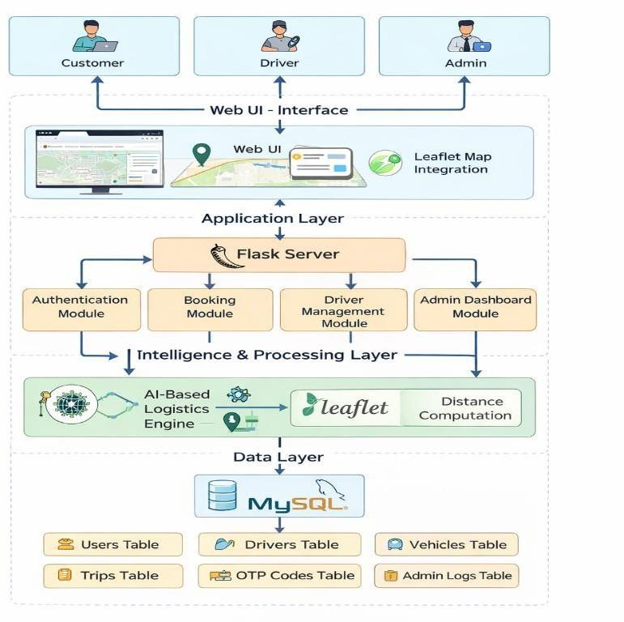
Figure 4.1 System Architecture

Module Design
The QuickLoad system is divided into well-defined modules, each responsible for a specific functionality. This modular design improves system clarity, simplifies maintenance, and enables independent enhancement of individual components without affecting the overall system.

User Management & Authentication Module
This module handles all user-related operations including registration, login, email verification, password security, and session management. It ensures that only authenticated and verified users can access system features.
Key responsibilities of this module include:

      - Customer registration with input validation
      - Secure login using hashed passwords

      - OTP-based email verification
      - Password reset using OTP authentication
      - Session creation and termination
      - Role-based access control (Customer / Driver / Admin)

This module significantly enhances platform security and prevents unauthorized access.

Driver & Vehicle Management Module
The Driver & Vehicle Management Module is responsible for onboarding and managing goods vehicle owners. It ensures that only verified drivers and vehicles are allowed to participate in transport operations.
      - Major functionalities include:
      - Driver registration with personal and contact details
      - Upload and storage of identity and vehicle documents
      - Vehicle registration and insurance validation
      - Application ID generation and QR code creation
      - Application status tracking
      - Administrative approval and rejection workflow

This module improves trust, accountability, and service quality across the platform.

Booking & Trip Management Module
This module manages the complete lifecycle of a transport request, from booking initiation to trip completion. It acts as the operational backbone of the system.
Core functions include:

      - Pickup and drop location selection
      - Load and vehicle type specification
      - Trip request creation
      - Driver assignment and acceptance
      - Trip status updates (Pending, Accepted, Completed)
      - Customer feedback and rating

This module ensures smooth coordination between customers and drivers.

Map & Route Visualization Module (Leaflet)

This module provides geospatial visualization features using Leaflet, an open-source mapping library. It replaces Google Maps to eliminate paid API dependency while maintaining accurate and interactive mapping.
Functions include:

      - Interactive map display for pickup and drop locations
      - Marker placement for source and destination
      - Route visualization
      - Distance estimation support
      - Lightweight and fast rendering
      - Using Leaflet improves system affordability and technical feasibility.

AI-Based Pricing & Allocation Module
This module implements the intelligent logic of the QuickLoad platform. It determines optimal pricing and vehicle allocation using multiple parameters.
Key factors considered:

      - Geographical distance
      - Vehicle type and capacity
      - Load weight
      - Operational constraints
      - Demand conditions

The AI engine ensures transparent, fair, and data-driven pricing without manual negotiation.

Admin Dashboard & Monitoring Module
This module provides administrative control and system oversight. It enables effective governance and monitoring of platform activities.
Administrative features include:

      - Secure admin login
      - Driver and vehicle approval management
      - Trip monitoring and reporting
      - User management
      - Revenue and performance analytics

      - System audit and control

This module ensures reliability, compliance, and operational transparency.

Database Design
Database design plays a critical role in ensuring data consistency, integrity, and efficient retrieval in any large-scale web application. For the QuickLoad platform, a relational database model is adopted using MySQL, as it provides strong transactional support, structured storage, and efficient handling of complex relationships among system entities.
The database is designed to support multiple user roles, secure authentication, vehicle and driver management, trip booking workflows, OTP verification, and administrative monitoring. The schema follows normalization principles to minimize redundancy while maintaining performance and scalability.

ER Diagram
The Entity Relationship (ER) Diagram represents the logical structure of the QuickLoad database, illustrating entities, their attributes, and relationships. It serves as a blueprint for database implementation and helps in understanding data flow within the system.
Key Entities Identified

      - User
      - Driver
      - Vehicle
      - Trip
      - OTP Verification
      - Admin Logs Relationship Overview
      - A User can create multiple Trips
      - A Driver can handle multiple Trips
      - A Driver can register one or more Vehicles
      - Each Trip is associated with one User and one Driver
      - OTP records are linked to Users for authentication
      - Admin logs track system-level activities

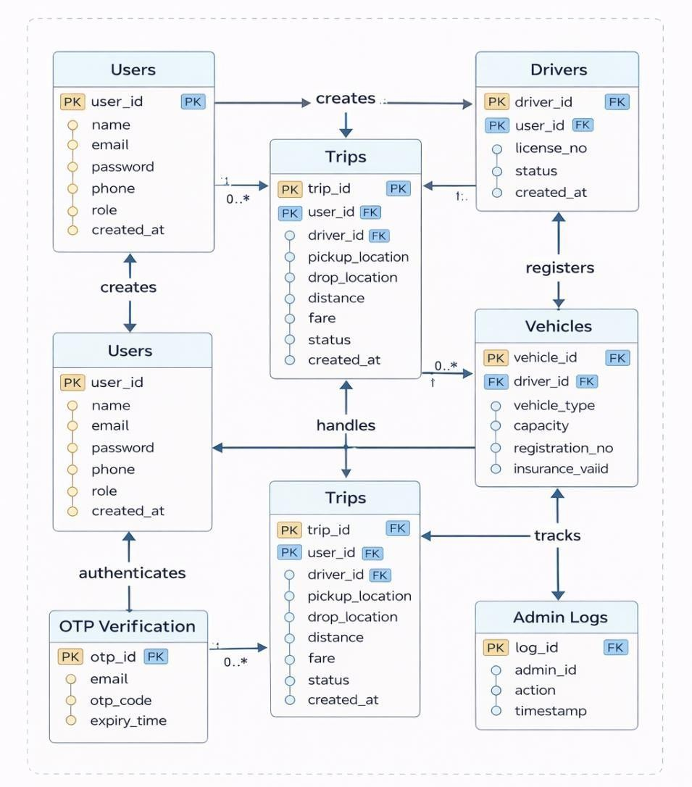
Figure 4.2 ER Diagram

Entity Descriptions:
User Entity

      - Stores customer account information

      - Each user can initiate multiple transport requests Driver Entity
      - Contains driver details and verification status

      - Linked with registered vehicles and trips Vehicle Entity
      - Stores vehicle specifications and capacity

      - Associated with a specific driver Trip Entity

      - Captures booking lifecycle details

      - Acts as the core transactional entity OTP Entity
      - Supports secure authentication and verification

      - Temporarily stores OTP codes with timestamps Admin Logs Entity
      - Maintains audit records for administrative actions

Database Schema
The database schema defines the physical structure of tables, attributes, and constraints used to store data in MySQL. Each table is designed with appropriate primary keys and foreign keys to enforce referential integrity.

Field Name | Data Type | Description
user_id (PK) | INT | Unique user identifier
name | VARCHAR | User full name
email | VARCHAR | Registered email address
password | VARCHAR | Encrypted password
phone | VARCHAR | Contact number
role | VARCHAR | User role (Customer/Admin)
created_at | TIMESTAMP | Account creation time
Table 4.1 Users Table

Field Name | Data Type | Description
driver_id (PK) | INT | Unique driver identifier
user_id (FK) | INT | Linked user account
license_no | VARCHAR | Driving license number
status | VARCHAR | Approval status

created_at | TIMESTAMP | Registration time
Table 4.2 Drivers Table

Field Name | Data Type | Description
vehicle_id (PK) | INT | Unique vehicle identifier
driver_id (FK) | INT | Associated driver
vehicle_type | VARCHAR | Type of vehicle
capacity | FLOAT | Load capacity
registration_no | VARCHAR | Vehicle number
insurance_valid | BOOLEAN | Insurance status
Table 4.3 Vehicles Table

Field Name | Data Type | Description
trip_id (PK) | INT | Unique trip identifier
user_id (FK) | INT | Customer
driver_id (FK) | INT | Assigned driver
pickup_location | TEXT | Pickup address
drop_location | TEXT | Drop address
distance | FLOAT | Trip distance
fare | FLOAT | Calculated fare
status | VARCHAR | Trip status
created_at | TIMESTAMP | Booking time
Table 4.4 Trips Table

Field Name | Data Type | Description
otp_id (PK) | INT | Unique OTP record
email | VARCHAR | User email
otp_code | VARCHAR | One-time password

expiry_time | TIMESTAMP | OTP expiration
Table 4.5 OTP Verification Table

Field Name | Data Type | Description
log_id (PK) | INT | Log identifier
admin_id | INT | Admin user
action | TEXT | Action performed
timestamp | TIMESTAMP | Action time
Table 4.6 Admin Logs Table

User Interface Design
The User Interface (UI) of the QuickLoad platform is designed to provide a simple, intuitive, and role-based interaction experience for customers, drivers, and administrators. The interface design emphasizes usability, clarity, and minimal complexity while supporting essential logistics operations such as booking, vehicle allocation, verification, and monitoring.
The UI follows a structured navigation flow and uses responsive web components to ensure accessibility across different devices. Interactive maps are integrated using Leaflet, enabling real-time visualization of pickup and drop locations without dependency on paid mapping services.
Each interface screen is designed to support a specific function in the system and guide the user logically through the application workflow.

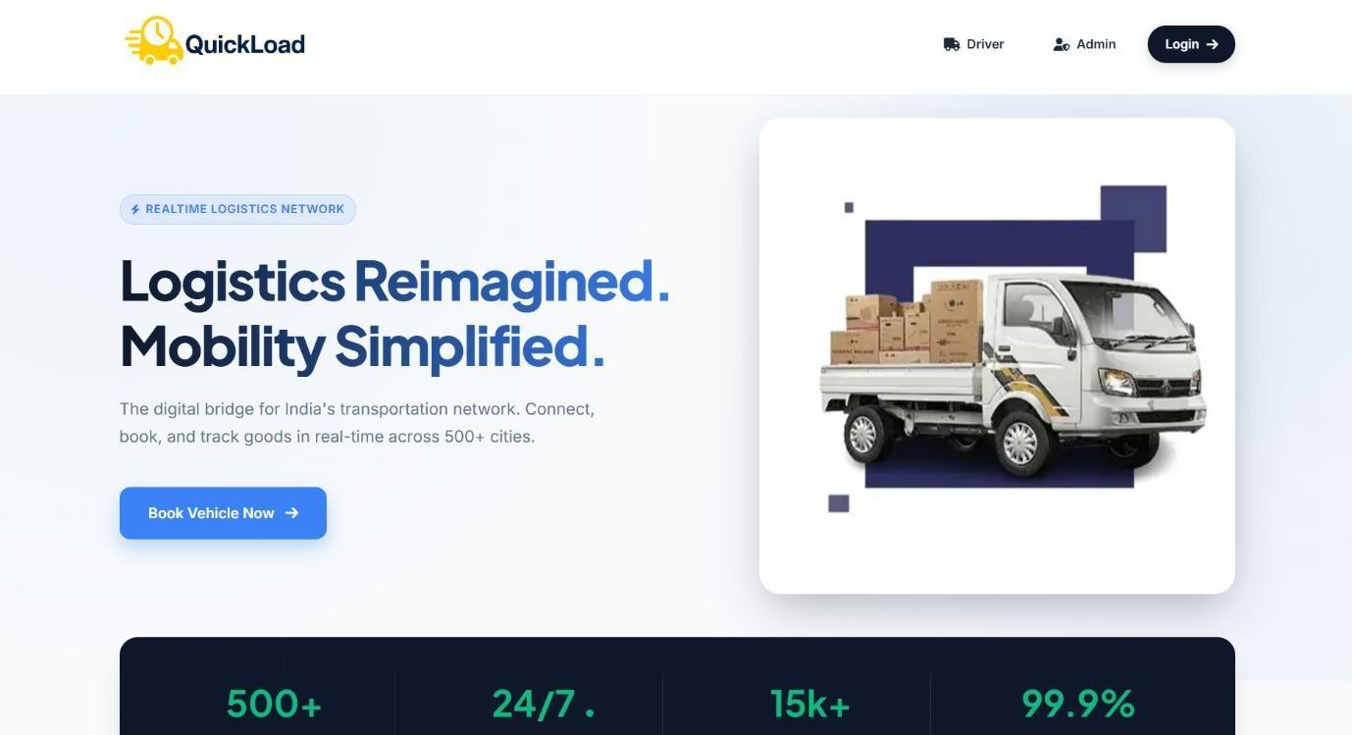

Figure 4.3 Landing Page

The Lannding Page acts as the entry point of the QuickLoad platform. It introduces the application and provides navigation options for user login and registration. The interface presents a clear overview of the platform’s purpose and ensures easy access to authentication features.
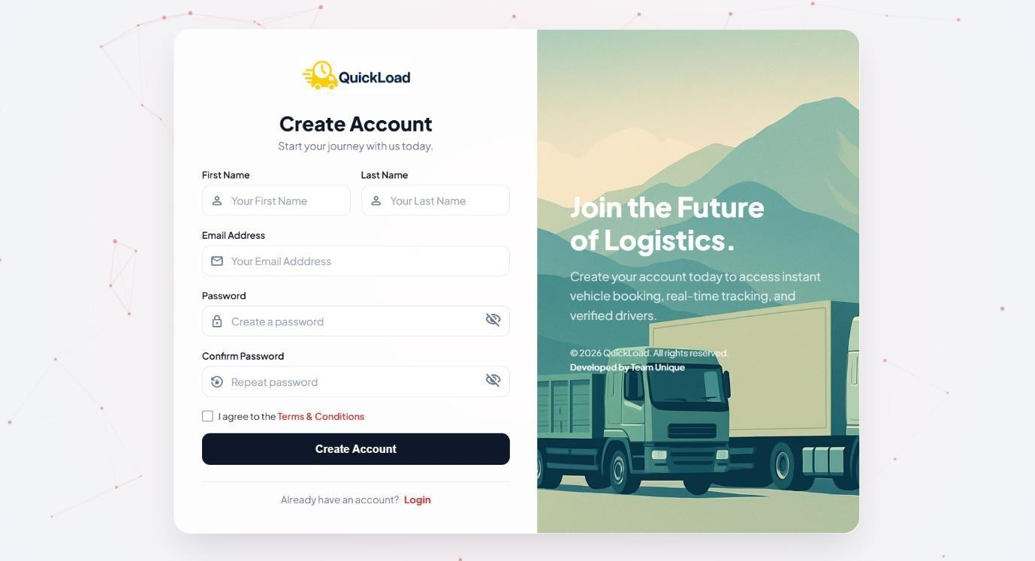
Figure 4.4 Customer SignUp Interface


Figure 4.5 OTP Verification

This screen allows new users to register by entering personal details such as name, email, phone number, and password. The system initiates OTP-based email verification after form submission to ensure user authenticity.
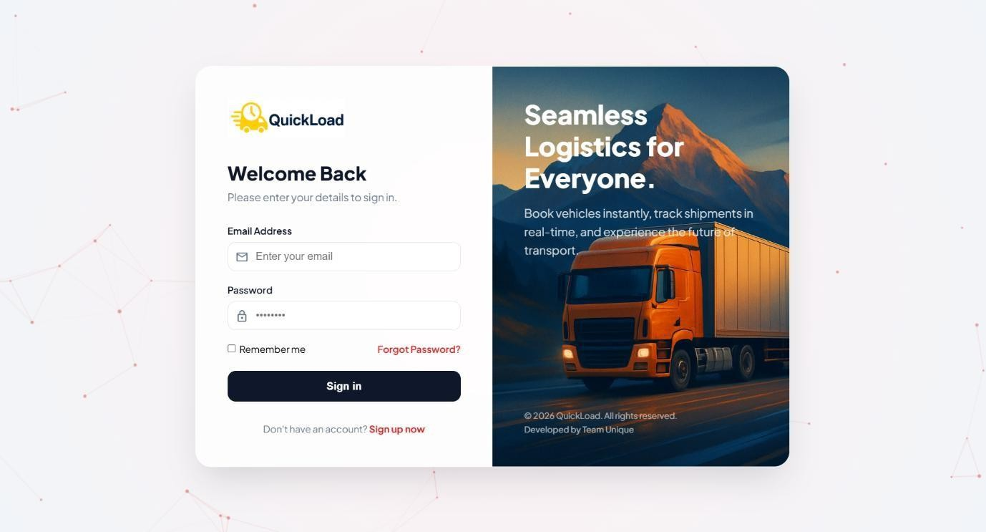
Figure 4.6 Customer Login Interface

The Login Page enables registered users to securely access the system using their credentials. The system validates credentials using encrypted password verification mechanisms.

User Flow Diagrams
User Flow Diagrams represent the step-by-step interaction between users and the system. These diagrams illustrate how different user roles navigate through the system to complete specific tasks such as registration, booking, trip management, and approval workflows.
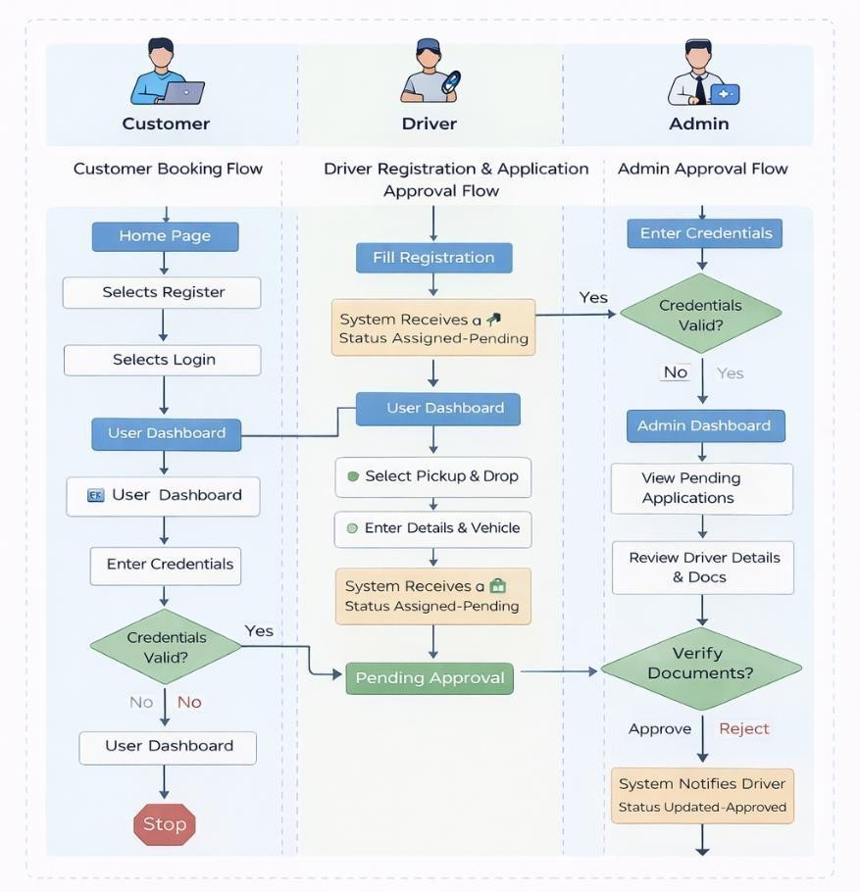
Figure 4.7 User Flow Diagram

The following user flows are identified in the QuickLoad platform:

      - Customer registration and booking flow

      - OTP verification and authentication flow

      - Driver registration and approval flow

      - Trip allocation and completion flow

      - Administrative monitoring and approval flow

  - Technology Stack

CHAPTER V IMPLEMENTATION

The successful implementation of the QuickLoad platform relies on a carefully selected technology stack that ensures scalability, security, performance, and ease of development. The technologies used are open-source, widely supported, and suitable for real-world deployment of web-based logistics applications.
The chosen stack supports:

- Rapid application development

- Secure user authentication

- Efficient database management

- Interactive geospatial visualization

- Modular and maintainable architecture

Programming Languages and Tools
Backend Technologies

      - Python: Used as the core programming language for backend development due to its simplicity, readability, and extensive library support.
      - Flask Framework: A lightweight web framework used to build RESTful web services, handle routing, session management, and backend logic.
      - MySQL: Relational Database Management System used for storing structured data such as users, drivers, vehicles, trips, OTPs, and admin logs.
Frontend Technologies

      - HTML5: Used to structure web pages.

      - CSS3: Used for styling and responsive layout design.

      - JavaScript: Used for client-side validation and interactive behavior.

      - Leaflet.js: Open-source mapping library used for map rendering, marker placement, and route visualization.
Security & Utility Tools

      - bcrypt: Used for secure password hashing.

      - SMTP / Email API: Used for sending OTPs during registration and password recovery.

      - UUID / QR Code Libraries: Used for generating application IDs and QR codes.

      - VS Code: Integrated Development Environment used for coding and debugging.

      - Git: Used for version control and code management.

Implementation of Modules
The QuickLoad system is implemented using a modular approach where each module performs a specific function and interacts with other modules through well-defined interfaces. This approach enhances maintainability, scalability, and debugging efficiency.

User Authentication and Management Module
This module handles user registration, login, OTP verification, and session management. During registration, user details are validated and stored securely in the database. Passwords are encrypted using bcrypt to prevent unauthorized access.
OTP-based email verification is implemented to ensure the authenticity of users. The OTP is generated dynamically, stored temporarily in the database with an expiry time, and validated during verification.
Key Features

      - Secure user registration and login

      - OTP-based email verification

      - Encrypted password storage

      - Role-based access control

Driver Registration and Vehicle Management Module

This module enables goods vehicle owners to register on the platform. Drivers submit personal information, vehicle details, and required documents. The system assigns a unique application ID and stores all details in the database.
The application remains in a pending state until reviewed by an administrator. Only approved drivers are allowed to access trip requests, ensuring trust and service quality.
Key Features

      - Driver and vehicle registration

      - Document upload and storage

      - Application status tracking

      - Admin approval workflow

Booking and Trip Management Module
This module manages the complete lifecycle of a goods transportation request. Customers can enter pickup and drop locations, specify load details, and select vehicle types. The system calculates distance and fare dynamically.
Once a booking is confirmed, a suitable driver is assigned based on availability and compatibility. Trip status updates are maintained throughout the journey.
Key Features

      - Trip creation and confirmation

      - Load and vehicle type selection

      - Fare estimation

      - Trip status tracking

Map and Route Visualization Module (Leaflet)
This module integrates Leaflet for geospatial visualization. It replaces Google Maps to avoid paid API dependency while providing interactive and accurate map functionality.
Pickup and drop locations are displayed using markers, and routes are visualized for user clarity. Distance computation supports pricing logic.
Key Features

      - Interactive maps using Leaflet

      - Marker-based location selection

      - Route visualization

      - Lightweight and fast rendering

AI-Based Pricing and Allocation Module
This module implements intelligent pricing and allocation logic. It computes fares based on multiple parameters such as distance, vehicle type, load weight, and operational constraints.
The algorithm ensures fair pricing and efficient resource utilization while reducing manual negotiation.
Key Features

      - Distance-based pricing

      - Load-aware cost calculation

      - Vehicle compatibility checks

      - Automated decision-making

Admin Dashboard and Monitoring Module
This module provides administrators with centralized control over system operations. Admins can approve drivers, monitor trips, manage users, and review logs.
Key Features

      - Secure admin login

      - Driver and vehicle approval

      - Trip monitoring

      - System audit logs

Integration of Modules
The integration of modules in the QuickLoad platform ensures seamless data flow and coordinated system behavior. Each module interacts with others through the Flask backend and shared database.

For example:

- The Authentication Module validates users before allowing access to booking features.

- The Booking Module interacts with the Pricing Module for fare calculation.

- The Driver Module communicates with the Admin Module for approval workflows.

- The Map Module integrates with the Booking Module for location selection and visualization.
This tightly coupled yet modular integration ensures:

- Data consistency

- Smooth user experience

- Scalability and maintainability

CHAPTER VI TESTING
Testing is a crucial phase in the software development lifecycle that ensures the correctness, reliability, security, and performance of the developed system. For the QuickLoad platform, a structured and systematic testing strategy was adopted to validate that all functional and non- functional requirements are met. The testing process focused on identifying defects at early stages, verifying module interactions, and ensuring that the system performs reliably under real-world conditions.
Multiple levels of testing were conducted, including unit testing, integration testing, system testing, and user acceptance testing. Each testing phase targeted specific aspects of the system to ensure complete coverage and robustness.

Testing Methodology
The testing methodology followed for QuickLoad is based on a black-box and functional testing approach, where system behavior is validated against expected outputs without analyzing internal code structure. Testing activities were performed incrementally as modules were developed, ensuring early detection and resolution of defects.
The methodology included:

- Test planning and identification of test scenarios

- Design of test cases based on requirements

- Execution of test cases and result analysis

- Logging and fixing identified defects

- Re-testing after bug fixes

This systematic approach ensured that the final system is stable, secure, and user-friendly.

Unit Testing
Unit testing focuses on testing individual modules or components in isolation to verify their correctness. Each module in the QuickLoad system was tested independently to ensure that it performs its intended functionality.

Unit testing was performed on core modules such as user authentication, OTP verification, booking creation, fare calculation, driver registration, and admin approval workflows. Inputs were validated, edge cases were tested, and exception handling was verified.
Objectives of Unit Testing

      - Verify correctness of individual functions

      - Detect logical errors at an early stage

      - Ensure proper input validation and error handling Modules Tested
      - User Registration and Login Module

      - OTP Generation and Verification Module

      - Booking and Fare Calculation Module

      - Driver Registration Module

      - Admin Approval Module

The results of unit testing confirmed that all individual components functioned correctly when tested independently.

Integration Testing
Integration testing was performed to verify the interaction between multiple modules and ensure that data flows correctly across the system. This phase focused on identifying issues that arise when different modules are combined.
For example, the integration between the authentication module and booking module was tested to ensure that only authenticated users can place booking requests. Similarly, the interaction between the booking module, pricing module, and map visualization module was validated to ensure accurate fare calculation and correct display of pickup and drop locations using Leaflet.
Objectives of Integration Testing

      - Validate communication between modules

      - Ensure consistency of shared data

      - Identify interface mismatches Integration Scenarios Tested
      - User authentication → Booking creation

      - Booking module → Pricing and distance computation

      - Driver registration → Admin approval

      - Approved drivers → Trip assignment

Integration testing results confirmed that all modules interacted seamlessly without data inconsistency or system failure.

System Testing
System testing evaluates the complete and fully integrated system to ensure that it meets all specified requirements. In this phase, the QuickLoad platform was tested as a whole in an environment similar to real-world deployment.
Functional testing was conducted to validate all user workflows, including customer booking, driver onboarding, and administrative management. Non-functional testing aspects such as performance, security, usability, and reliability were also evaluated.
Objectives of System Testing

      - Validate end-to-end system behavior

      - Ensure compliance with functional requirements

      - Assess performance and security System Testing Scenarios
      - Complete user registration and booking workflow

      - Driver registration, approval, and trip acceptance

      - Admin monitoring and reporting

      - Error handling and session management

The system testing phase confirmed that the QuickLoad platform operates correctly under normal and expected usage conditions.

User Acceptance Testing (UAT)
User Acceptance Testing (UAT) was conducted to validate whether the system meets user expectations and business requirements. This phase involved testing the system from the end- user perspective using real-world scenarios.
Sample users representing customers, drivers, and administrators interacted with the system to evaluate ease of use, clarity of interfaces, and overall satisfaction. Feedback collected during this phase was used to refine the user interface and improve usability.
Objectives of UAT

      - Validate system usability and user satisfaction

      - Ensure system meets real-world expectations

      - Identify usability improvements

UAT results indicated that users found the system intuitive, responsive, and reliable, confirming readiness for deployment.

Test Cases and Results
The following table summarizes representative test cases executed during the testing process.

Test Case ID | Module | Test Description | Expected Result | Actual Result | Status
TC01 | Authentication | Valid user login | Successful login | Successful | Pass
TC02 | Authentication | Invalid login credentials | Error message | Error displayed | Pass
TC03 | OTP Module | Valid OTP verification | Access granted | Access granted | Pass
TC04 | Booking | Create booking with valid data | Booking created | Booking created | Pass
TC05 | Pricing | Distance-based fare calculation | Correct fare | Correct fare | Pass
TC06 | Driver Module | Driver registration submission | Status pending | Status pending | Pass
TC07 | Admin Module | Approve driver application | Driver approved | Approved | Pass

TC08 | Map Module | Display pickup & drop locations | Map rendered | Map rendered | Pass
Table 6.1 Test Cases and Results

All test cases produced the expected results, indicating that the system functions as intended.

Bug Tracking and Resolution
Bug tracking and resolution were carried out continuously throughout the development and testing phases. Identified defects were logged, analyzed, and resolved systematically.
Common issues identified during early testing stages included input validation errors, session handling inconsistencies, and minor UI alignment problems. These issues were addressed by improving validation logic, enhancing session management, and refining UI layouts.
Bug Management Process

- Identification and logging of bugs

- Root cause analysis

- Fix implementation

- Re-testing to confirm resolution

No critical or high-severity bugs remained unresolved at the end of the testing phase. The system achieved a stable and reliable state suitable for deployment.

CHAPTER VII RESULTS AND DISCUSSION
This chapter presents the outcomes obtained after successful implementation and testing of the QuickLoad platform. The results are analyzed based on system outputs, evaluation metrics, comparison with existing systems, challenges encountered during development, and the solutions implemented to overcome them. The discussion highlights how the proposed system effectively addresses the limitations of traditional goods transportation platforms.

System Output Screenshots
This section illustrates the functional behavior of the QuickLoad system through screenshots captured during execution. The screenshots demonstrate successful operation of key modules and validate the correctness of the implemented features.
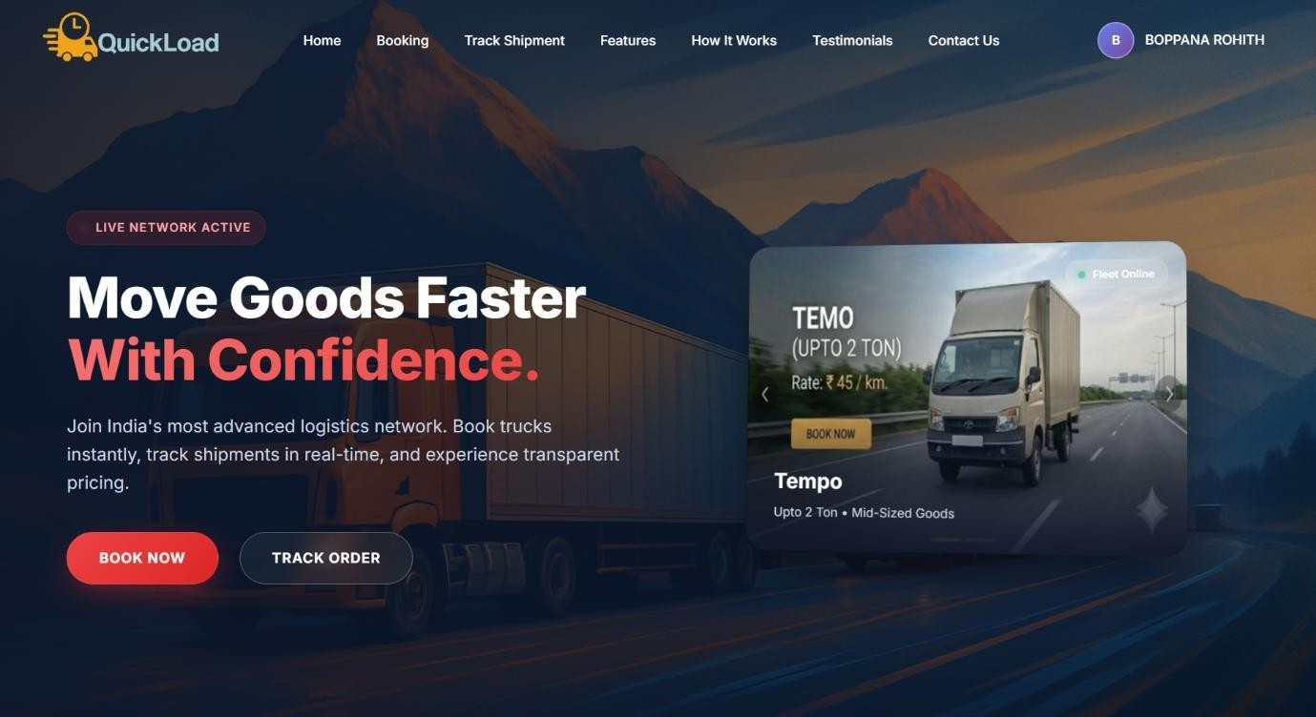
Figure 7.1 Customer Home Page

This screenshot shows the user dashboard interface after successful login, confirming proper session handling and role-based access.

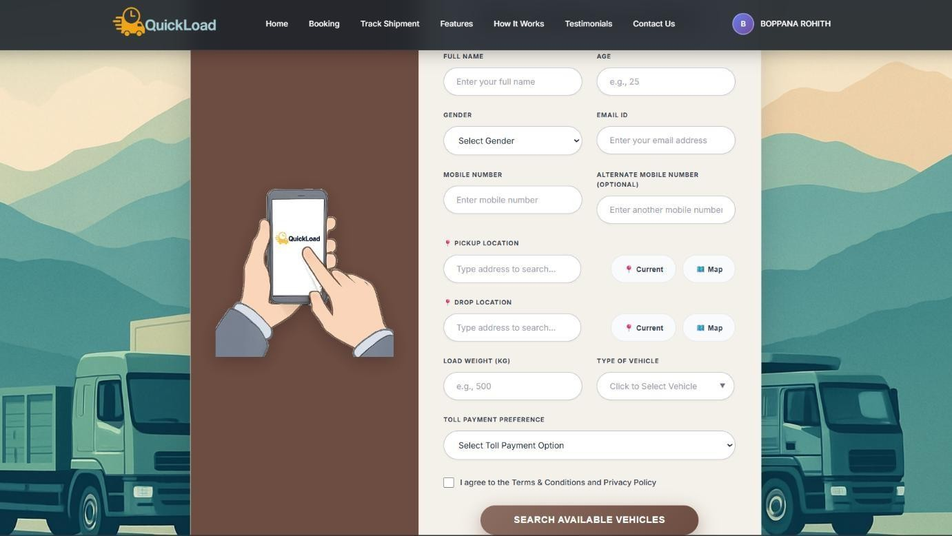
Figure 7.2 Customer Vehicle Booking Form

This screenshot displays the booking form where users enter pickup and drop locations, load details, and select vehicle type. The form integrates Leaflet-based map visualization and dynamically calculates fare based on distance and load parameters, confirming correct booking functionality.

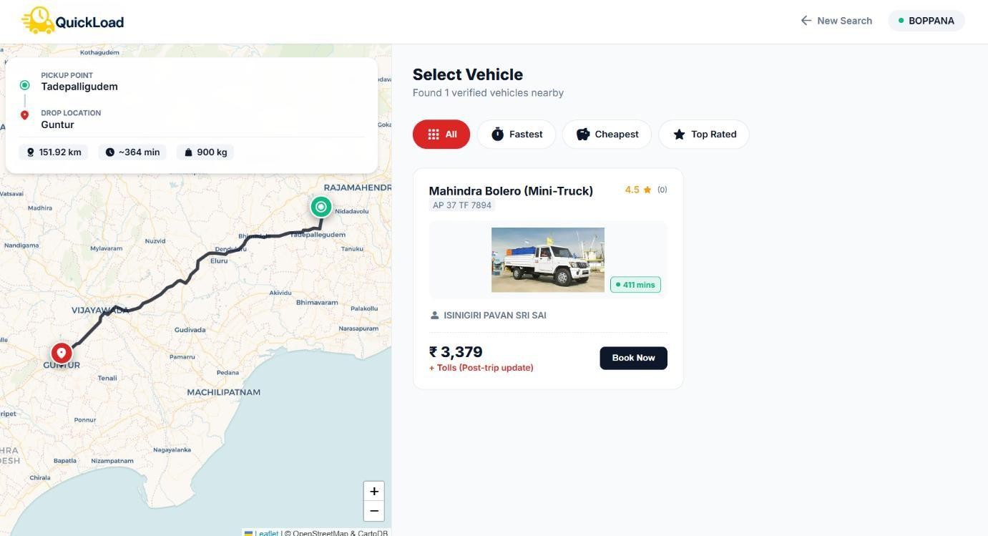
Figure 7.3 Vehicle Selection with Route Map

This screenshot displays the Leaflet-based map interface showing pickup and drop markers and route visualization, validating successful integration of open-source mapping.
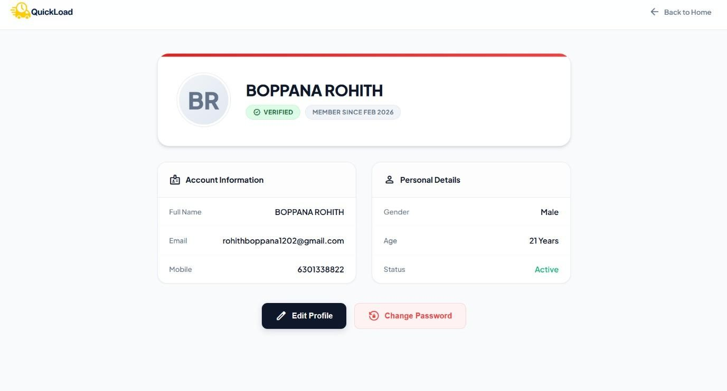
Figure 7.4 Customer Profile

This screenshot shows the user profile page containing personal details such as name, email, and contact information. It confirms proper retrieval and display of user data from the database.

Figure 7.5 Customer Bookings

This interface displays the list of bookings made by the user, along with booking status such as pending, ongoing, or completed. It validates correct trip tracking and history management.
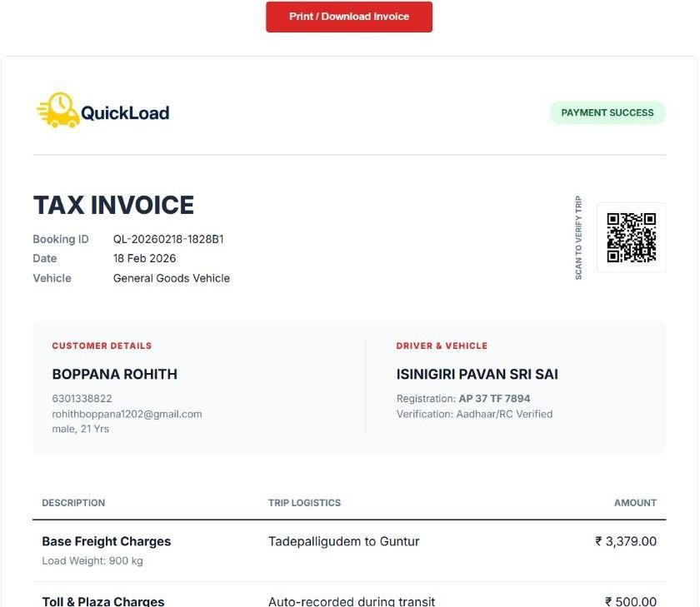
Figure 7.6 Customer Tax Invoice

This screenshot displays the Tax Invoice Bill generated after successful completion of a goods transportation trip in the QuickLoad platform.
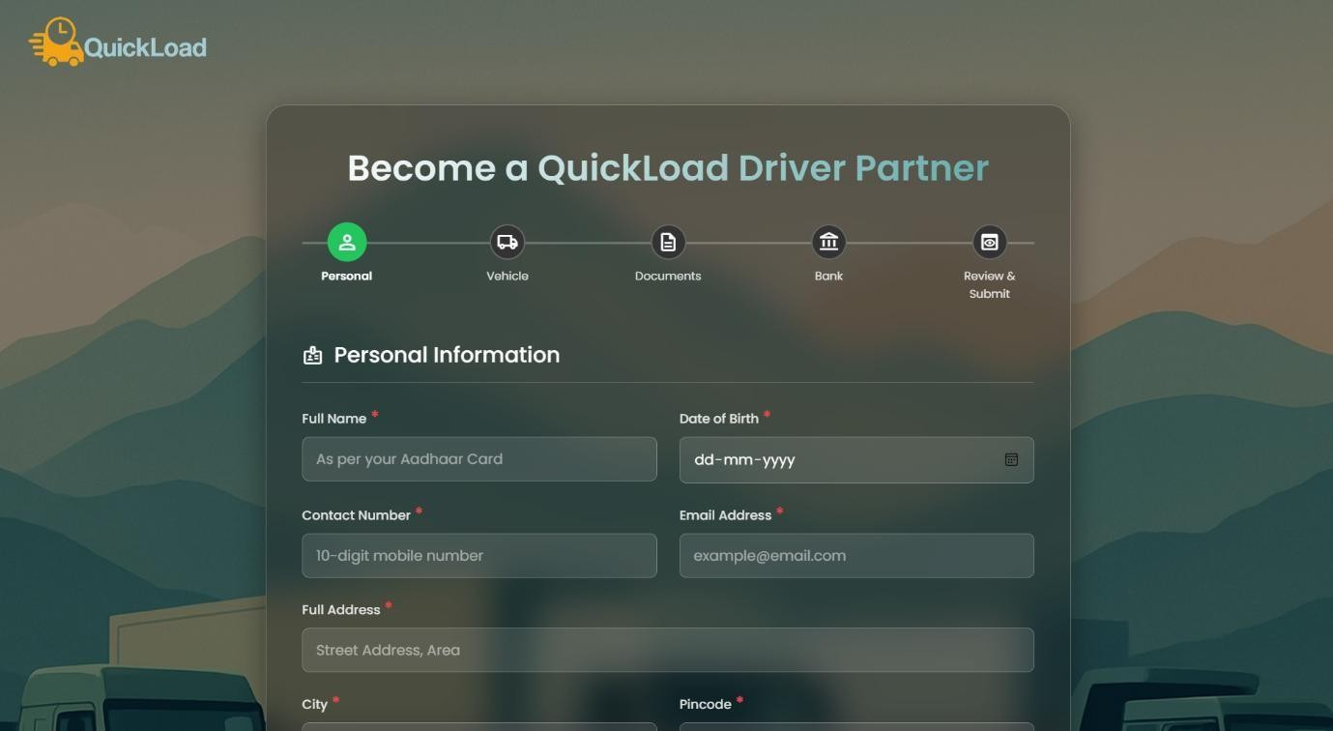
Figure 7.7 Driver Registration Page

This screenshot shows the driver registration interface where drivers submit personal details, vehicle information, and documents for verification. The page confirms successful onboarding workflow initiation.
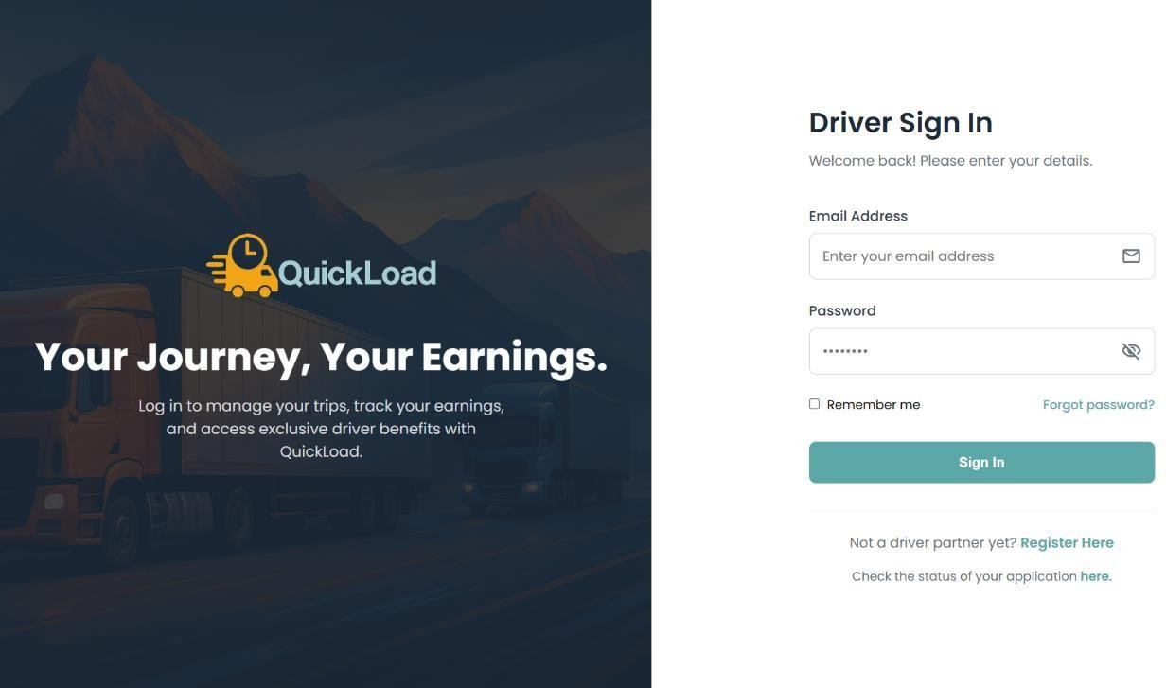
Figure 7.8 Driver Login Interface

This interface displays the driver login page, validating secure authentication using encrypted credentials and role-based access control.
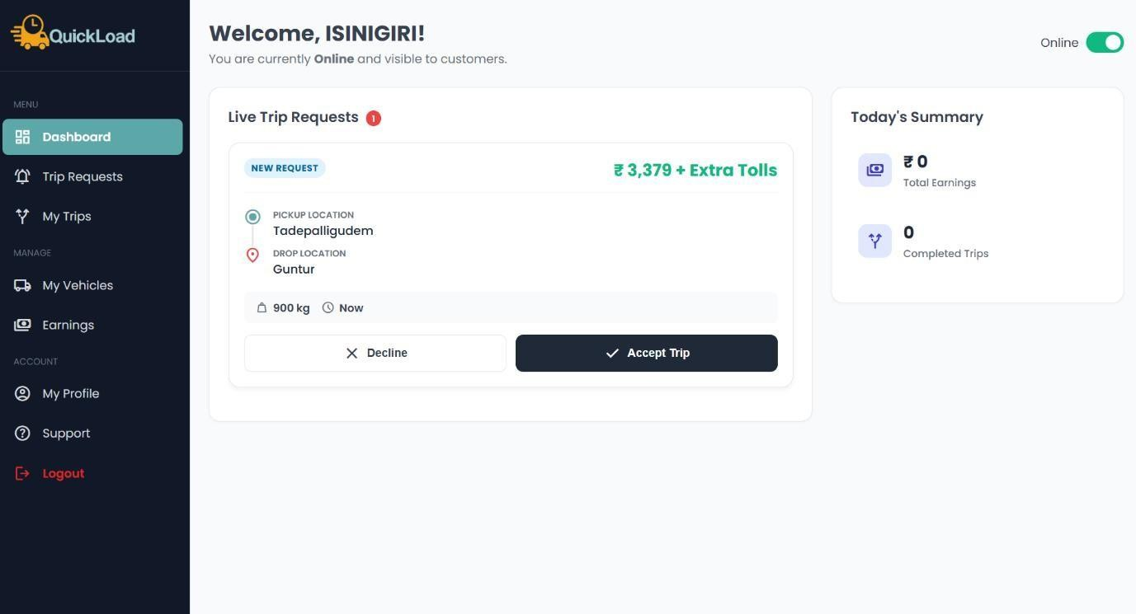
Figure 7.9 Driver Dashboard

This screenshot demonstrates the driver dashboard, showing available trips and trip status updates, confirming correct driver-side functionality.
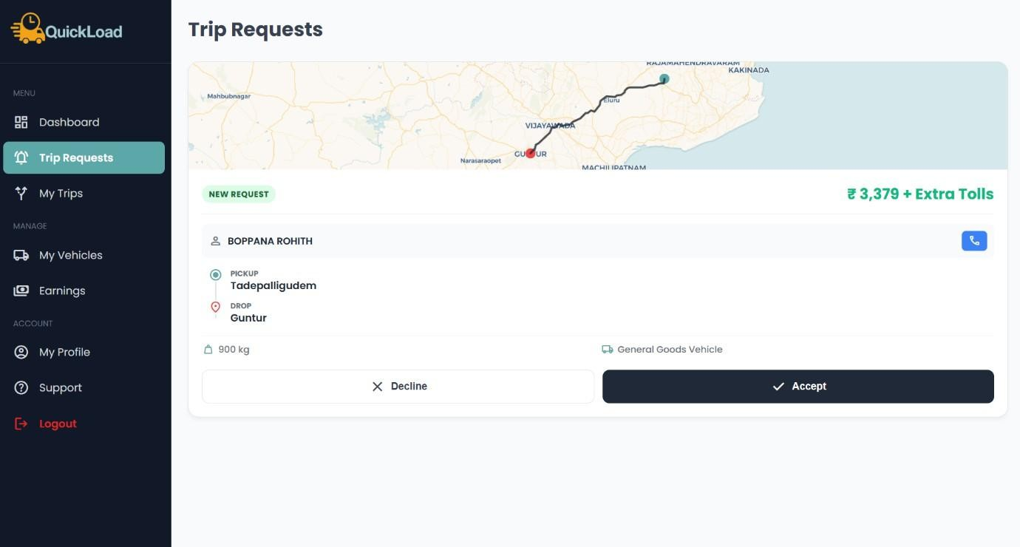
Figure 7.10 Driver Trip Requests

This screenshot shows the list of available trip requests visible to approved drivers. It validates correct trip allocation logic and real-time request visibility.
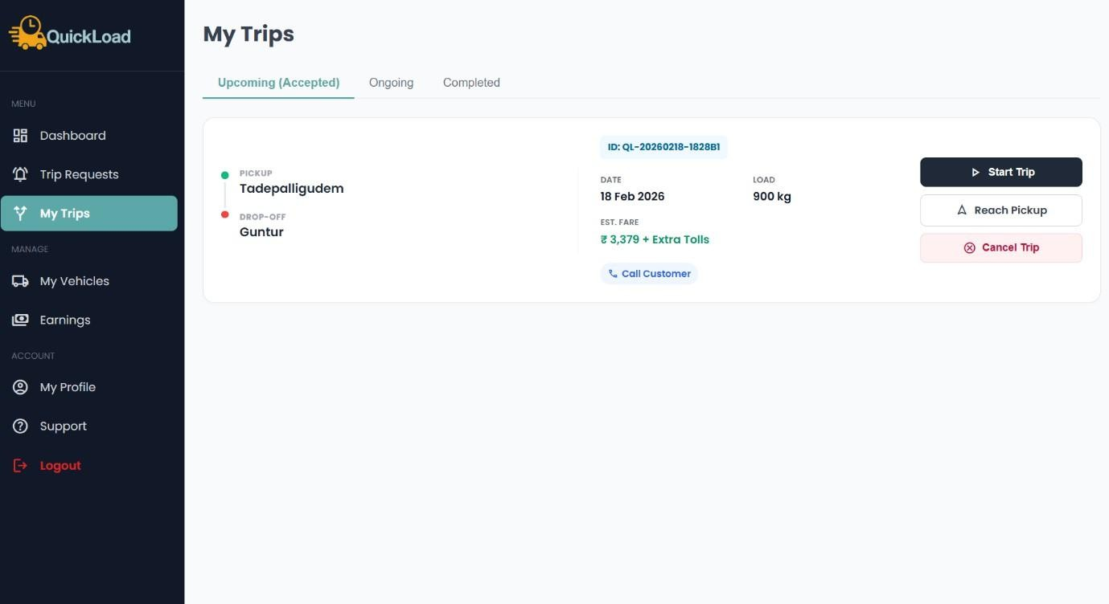
Figure 7.11 Driver Trips Page

This interface displays trips categorized as accepted, ongoing, and completed. It confirms proper trip lifecycle management and status updates.

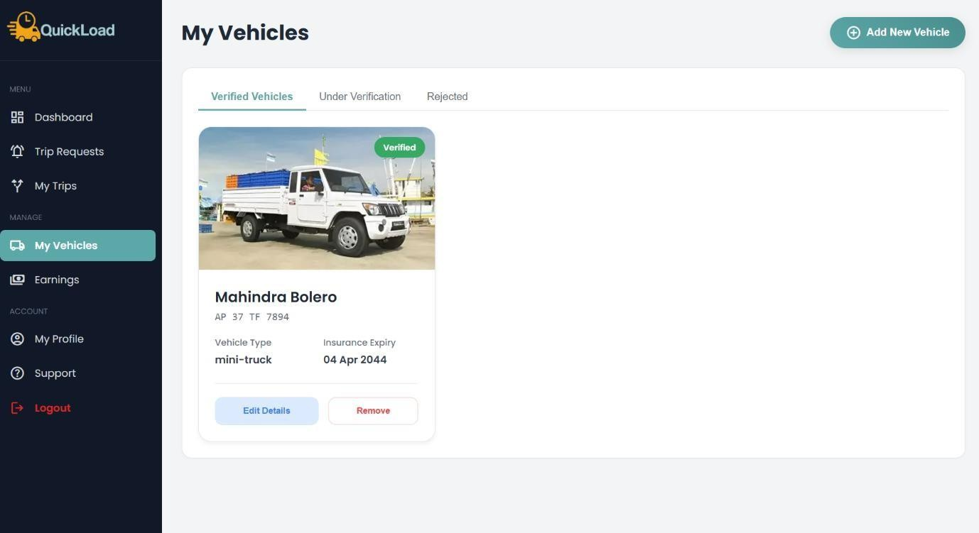
Figure 7.12 Manage Vehicles (Driver)

This screenshot shows vehicle details registered by the driver, including vehicle type, capacity, and approval status, confirming correct vehicle management functionality.
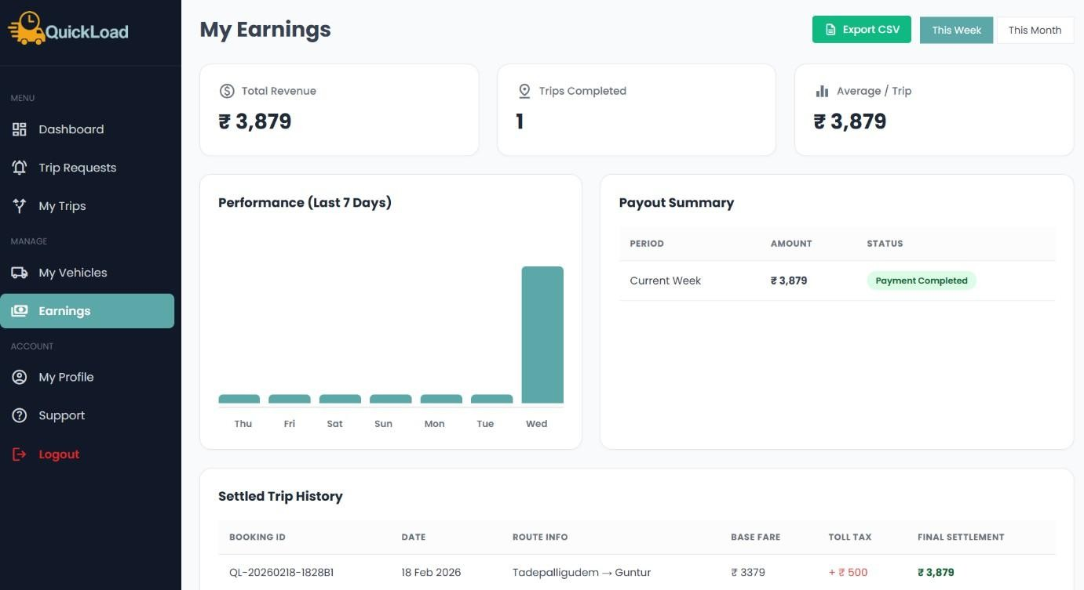
Figure 7.13 Driver Earnings

This interface displays earnings details for completed trips, validating accurate fare calculation, trip completion tracking, and earnings aggregation.

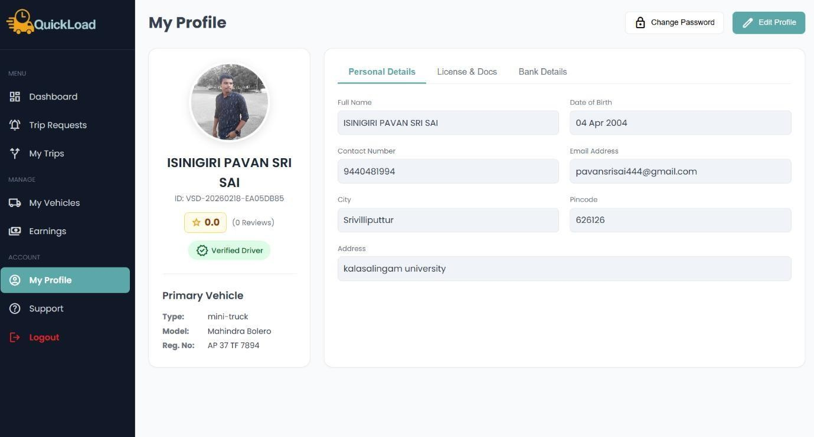
Figure 7.14 Driver Profile

This screenshot displays the driver profile page containing personal information, verification status, and account details, confirming proper profile data management.
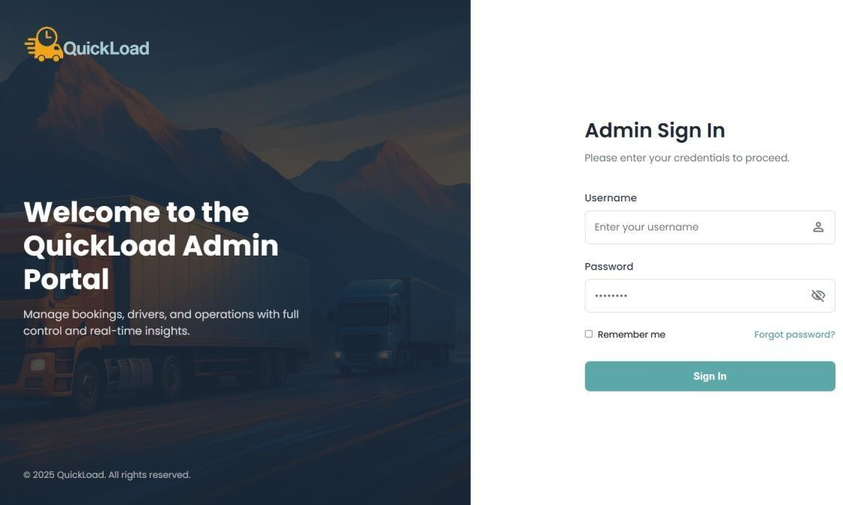
Figure 7.15 Admin Login Interface

This screenshot shows the admin login interface used to authenticate administrative users before accessing system controls.

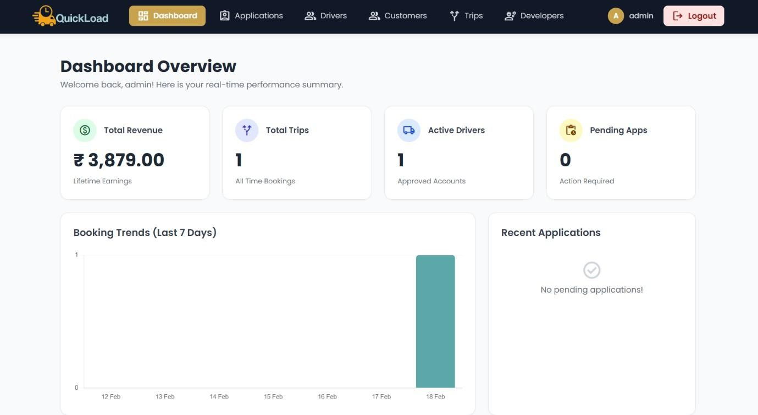
Figure 7.16 Admin Dashboard

This screenshot displays the admin dashboard where administrators can approve driver applications, monitor trips, and manage users.
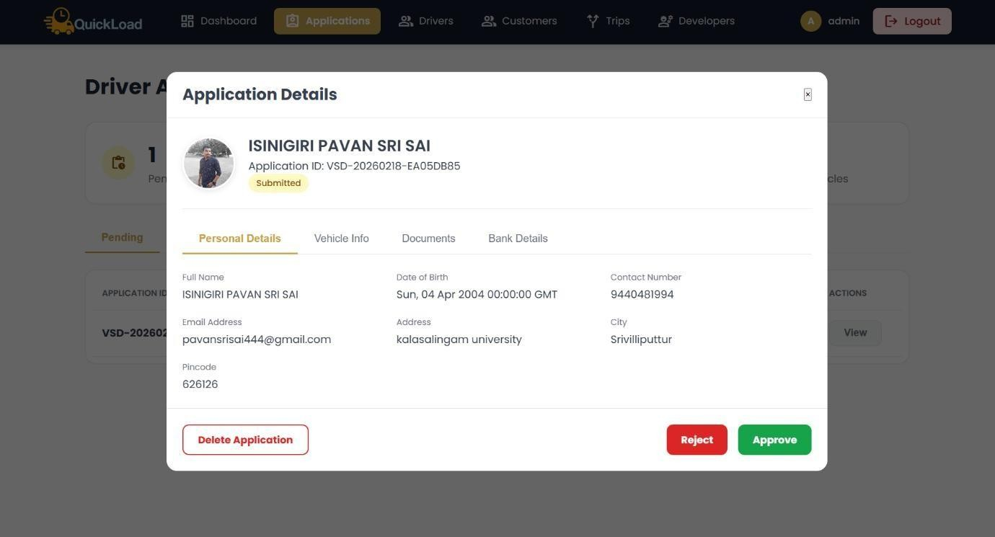
Figure 7.17 Driver Applications (Admin)

This interface displays pending driver applications along with uploaded documents. Admins can approve or reject applications, ensuring controlled onboarding.

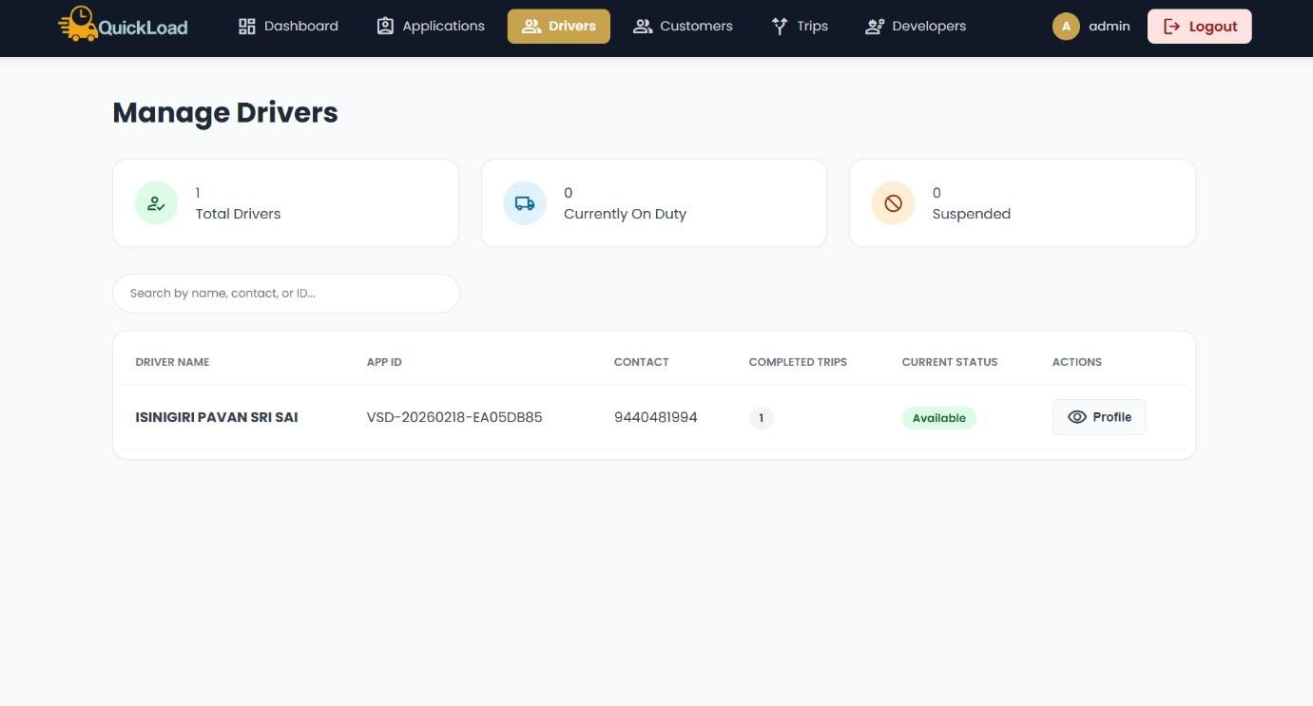
Figure 7.18 Manage Drivers & Vehicles

This screenshot shows the admin interface for managing registered drivers and vehicles, including status updates and monitoring.
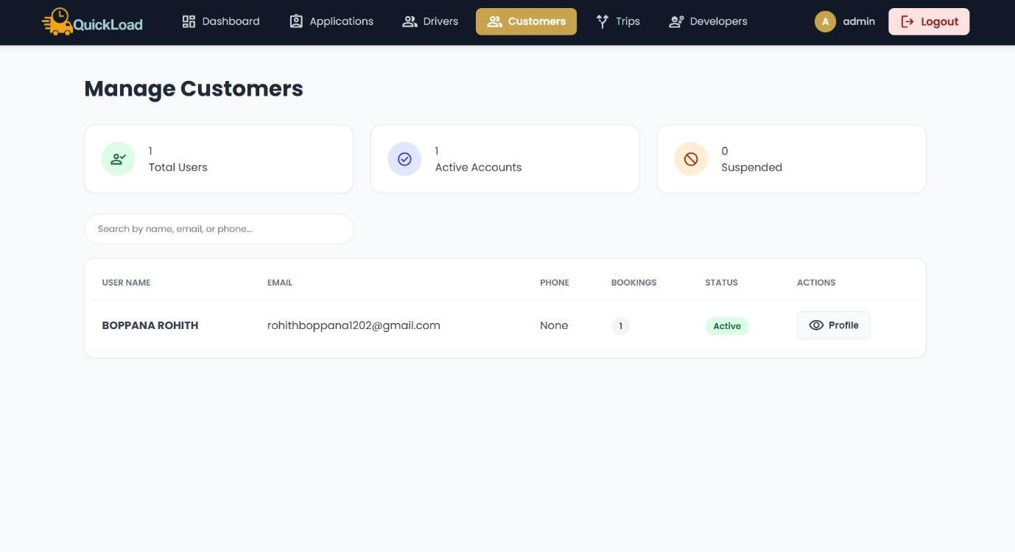
Figure 7.19 Manage Customers

This interface displays customer records and account details, allowing administrators to monitor user activity and manage accounts.

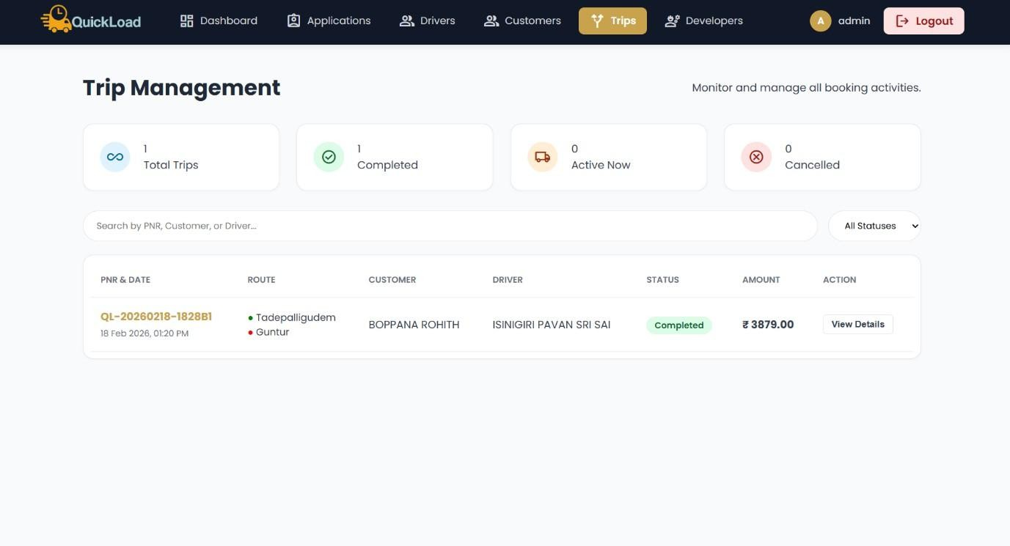
Figure 7.20 Manage Trips

This screenshot shows the trips management interface where admins can monitor all bookings, driver assignments, and trip statuses.

Figure 7.21 Manage Developers

This interface displays developer and project team information, validating proper informational page integration within the system.

Evaluation Metrics

The performance and effectiveness of the QuickLoad system were evaluated using several qualitative and quantitative metrics. These metrics help in assessing system reliability, efficiency, usability, and scalability.
Key Evaluation Metrics

    - Response Time: Measures the time taken to process booking requests and load interfaces.
    - Accuracy of Fare Estimation: Evaluates correctness of distance-based and load-aware pricing.
    - System Reliability: Assesses system stability under continuous usage.

    - Usability: Measures ease of navigation and user satisfaction.

    - Security: Evaluates robustness of authentication and data protection mechanisms.

Observations

    - The system demonstrated fast response times for booking and map loading.

    - Fare calculations were consistent and transparent.

    - Leaflet-based mapping provided smooth and accurate visualization.

    - Users reported ease of use and clarity in navigation.

    - Authentication and OTP verification worked reliably without failures.

Comparison with Existing Systems
The proposed QuickLoad system was compared with traditional goods transportation systems and existing online logistics platforms.

Feature | Existing Systems | QuickLoad System
Middlemen Dependency | High | Eliminated
Pricing Transparency | Low | High
Map Integration | Paid APIs | Open-source Leaflet
Authentication Security | Basic | OTP-based & encrypted
Driver Verification | Limited | Admin-approved
Scalability | Moderate | High

User Experience | Complex | User-friendly
Table 7.1 Comparison with Existing Systems

Traditional systems rely heavily on intermediaries, leading to increased costs and delays. Existing platforms often depend on paid mapping services and lack transparent pricing mechanisms. QuickLoad overcomes these issues by offering direct user-driver interaction, intelligent pricing, and open-source map integration.

Challenges Faced
During the development and implementation of the QuickLoad platform, several challenges were encountered:
    - Designing secure OTP-based authentication

    - Managing role-based access for users, drivers, and admins

    - Replacing Google Maps with Leaflet while maintaining accuracy

    - Ensuring smooth integration between modules

    - Handling session management and data consistency

    - Designing a scalable and maintainable architecture

These challenges required careful planning, testing, and iterative improvements.

Solutions and Improvements
The identified challenges were addressed using effective technical and design solutions:

    - OTP authentication was implemented with expiry-based validation.

    - Role-based access control ensured secure and restricted operations.

    - Leaflet was integrated successfully using open-source tiles and routing logic.

    - Modular design simplified integration and debugging.

    - Improved validation logic enhanced data consistency.

    - UI refinements improved usability and user satisfaction.

Key Improvements Achieved

    - Enhanced system security and reliability

    - Reduced operational costs by eliminating paid APIs

    - Improved transparency and fairness in pricing

    - Better scalability and maintainability

    - Positive user feedback and acceptance

Conclusion

CHAPTER VIII CONCLUSION & FUTURE SCOPE

The QuickLoad platform was successfully designed, implemented, and evaluated as a smart, web-based goods transportation system that addresses the limitations of traditional logistics services. The primary objective of the project was to develop a secure, transparent, and efficient platform that directly connects customers with goods vehicle owners while eliminating the dependency on intermediaries.The system integrates modern web technologies with intelligent decision-making mechanisms to provide real-time booking, fare estimation, and vehicle allocation.

Future Scope
Although the QuickLoad platform meets its current objectives, there is significant scope for future enhancements and expansion. Potential improvements that can further strengthen the system are outlined below:
Mobile Application Development:

    - Development of dedicated Android and iOS applications to improve accessibility and user engagement.
Real-Time GPS Tracking:

    - Integration of live vehicle tracking to provide real-time trip monitoring and enhanced transparency.
Advanced AI and Predictive Analytics:

    - Implementation of machine learning models for demand forecasting, route optimization, and dynamic pricing based on historical data.
Online Payment Gateway Integration:

    - Support for digital payments, wallets, and invoicing to enable seamless cashless transactions.

REFERENCES

- R. Dintén, S. García, and M. Zorrilla, “Fleet management systems in Logistics 4.0 era: A real-time distributed and scalable architectural proposal,” Procedia Computer Science, vol. 217, pp. 806–815, 2023.
- Kotsialos and P. Vassilakopoulou, “Fleet management enterprise systems and traffic control synergies: A literature review and research agenda,” Procedia Computer Science, vol. 219, pp. 529–536, 2023.
- Dui, S. Zhang, M. Liu, X. Dong, and G. Bai, “IoT-enabled real-time traffic monitoring and control management for intelligent transportation systems,” IEEE Internet of Things Journal, vol. 11, no. 9, pp. 15842–15854, 2024.
- Y. Yin, H. Wang, and X. Deng, “Real-time logistics transport emission monitoring: Integrating artificial intelligence and Internet of Things,” Transportation Research Part D: Transport and Environment, vol. 136, p. 104426, 2024.
- Elassy, M. Al-Hattab, M. Takruri, and S. Badawi, “Intelligent transportation systems for sustainable smart cities,” Transportation Engineering, vol. 16, p. 100252, 2024.
- A. Hazarika, N. Choudhury, M. M. Nasralla, S. B. A. Khattak, and I. U. Rehman, “Edge ML technique for smart traffic management in intelligent transportation systems,” IEEE Access, vol. 12, pp. 25443–25458, 2024.
- R. Zhang, J. Mao, H. Wang, B. Li, X. Cheng, and L. Yang, “A survey on federated learning in intelligent transportation systems,” IEEE Transactions on Intelligent Vehicles, 2024.
- X. Zhou, W. Liang, A. Kawai, K. Fueda, J. She, and K. I. K. Wang, “Adaptive segmentation enhanced asynchronous federated learning for sustainable intelligent transportation systems,” IEEE Transactions on Intelligent Transportation Systems, vol. 25, no. 7, pp. 6658–6666, 2024.
- Belkacem, “Integrating edge and cloud computing for efficient big data processing in IoT environments: Enhancing smart city applications with fog computing,” Studies in Knowledge Discovery, Intelligent Systems, and Distributed Analytics, vol. 14, no. 9, pp. 1–14, 2024.
- Afzal, Z. Ahmad, and A. Algarni, “A latency-aware and fault-tolerant framework for resource scheduling and data management in fog-enabled smart city transportation systems,” Computers, Materials & Continua, vol. 82, no. 1, 2025.

An Edge-Assisted Architecture for Context- Aware Matching in Real-Time Goods Transportation Systems

N. R. Sathis Kumar B. Rohith B. Yaswanth Babu

Department of computer Science and Engineering
Kalasalingam Academy of Research and Education
Department of computer Science and Engineering
Kalasalingam Academy of Research and Education
Department of computer Science and Engineering
Kalasalingam Academy of Research and Education

Krishnankovil, India Krishnankovil, India Krishnankovil, India
sathiskumar@klu.ac.in 99220041454@klu.ac.in 99220041445@klu.ac.in

A. Sai Prajwin Y. Vinayasree

Department of computer Science and Engineering
Kalasalingam Academy of Research and Education
Department of computer Science and Engineering
Kalasalingam Academy of Research and Education

Krishnankovil, India Krishnankovil, India
99220041438@klu.ac.in 99220041423@klu.ac.in

Abstract—Because of centralized architectures, slow response times, and reliance on middlemen, the logistics industry consistently struggles to effectively match the demands for the transportation of goods with the availability of vehicles. An edge-assisted architecture for context-aware, real-time matching in decentralized goods transportation systems is proposed in this paper. The system distributes computational loads among localized edge nodes, reduces latency, and supports offline-resilient operations by utilizing a hybrid edge–cloud infrastructure. In order to optimize vehicle allocation, a novel context-aware matching algorithm is presented that integrates driver trust scores, historical reliability, load compatibility, geospatial proximity, and real-time traffic conditions. By placing edge micro-controllers at key network locations, localized decision-making is made possible and the need for constant cloud connectivity is decreased. Comparing experimental evaluations to traditional centralized models reveals significant gains in booking efficiency, decreased vehicle idle time, and quicker response rates. Through transparent, technologically driven service accessibility, this architecture not only improves system responsiveness and scalability but also gives independent transport operators more power. The suggested solution is a first step toward distributed logistics platforms that are intelligent and flexible enough to operate in resource-constrained and urban settings.
Keywords—Real-Time Transportation Systems, Edge Computing, Context-Aware Matching, Hybrid Edge–Cloud Architecture, Decentralized Booking Platforms, Vehicle Allocation Optimization, Sustainable Development Goal 8 (Decent Work and Economic Growth), Sustainable Development Goal 11 (Sustainable Cities and Communities)
I. Introduction
Logistics and transportation networks are under unprecedented pressure to become faster, more adaptive, and more intelligent due to the exponential growth of e-commerce, urbanization, and consumer expectations [1], [2]. Due to intrinsic constraints like high latency, inadequate scalability,
and a lack of contextual intelligence, traditional centralized fleet management systems frequently fail to meet these demands [3], [4]. These drawbacks are especially noticeable in underserved and geographically diverse areas, where reliance on cloud-based operations frequently causes disruptions and network infrastructure may be unreliable [5].
A new era of intelligent logistics has been made possible by the development of edge computing, the Internet of Things (IoT), and artificial intelligence (AI). Bringing computation closer to the data source, edge computing in particular enables real-time processing, reduced latency, and offline-resilient system behavior—features essential to sustaining uninterrupted service in logistics environments. The integration allows for highly optimized, dynamic, and scalable transport services when paired with context-aware systems that can evaluate factors such as driver history, load compatibility, vehicle availability, and route congestion.
In light of contemporary smart cities and rural areas that are being digitally transformed, the necessity for a decentralized and intelligent framework becomes even more apparent. Real-time responsiveness is crucial in these situations for sustainability, safety, and efficiency. However, cloud-dependent platforms frequently experience service degradation under high load or limited connectivity, and they frequently introduce latency due to distance from the data source. By facilitating quicker, more pertinent decision- making and lowering the communication overhead between nodes and central servers, edge computing—enhanced with federated intelligence and localized data processing— addresses these issues.
Intelligent Transportation Systems (ITS) have advanced, but current implementations are still mostly cloud-centric and do not have the adaptive capabilities needed for fine-grained, real-time edge decision-making. Furthermore, a lot of current systems use rule-based or static allocation strategies that don't take dynamically changing logistical conditions into

979-8-3315-5864-2/25/$31.00 ©2025 IEEE

 Page 2 of 10 - Integrity Overview Submission ID

6% Overall Similarity
The combined total of all matches, including overlapping sources, for each database.
Match Groups Top Sources

15 Not Cited or Quoted 3% | 4% | Internet sources
Matches with neither in-text citation nor quotation marks | 4% | Publications
1 Missing Quotations 0%  Matches that are still very similar to source material | 2% | Submitted works (Student Papers)
9 Missing Citation 3%
Matches that have quotation marks, but no in-text citation
0 Cited and Quoted 0%
Matches with in-text citation present, but no quotation marks

Integrity Flags

0 Integrity Flags for Review
No suspicious text manipulations found.


Page 2 of 10 - Integrity Overview Submission ID


4/2/26, 12:06 PM Kalasalingam Academy of Research and Education Mail - Paper #680 Acceptance Notification | Fourth IEEE Delhi Section Co…

BOPPANA ROHITH 2022-CSE <99220041454@klu.ac.in>

Paper #680 Acceptance Notification | Fourth IEEE Delhi Section Conference DELCON2025 (International Conference on Recent Smart Technologies in Engineering for Sustainable Development)
1 message

Microsoft CMT <noreply@msr-cmt.org> Sat, Sep 20, 2025 at 10:24 PM To: Rohith Boppana <99220041454@klu.ac.in>

Dear Rohith Boppana ,
We are pleased to inform you that your paper #680 titled "An Edge-Assisted Architecture for Context- Aware Matching in Real-Time Goods Transportation Systems", has been accepted for presentation at the
Fourth IEEE Delhi Section Conference DELCON2025 (International Conference on Recent Smart Technologies in Engineering for Sustainable Development). The reviewers appreciated your contribution. You are
advised to see their comments available through your author's console (https://cmt3.research. microsoft.com/DELCON2025/) on the CMT portal and accommodate all feedback/comments in preparation of your camera-ready paper.
Next Steps:
- Camera-ready Paper Submission (Deadline Oct 10th, 2025)
All authors who intend to present at the conference must submit a camera-ready version of their paper compliant with IEEE standards latest by 10/10/2025. Please visit the following link for detailed
instructions (recommended browser is Google Chrome).

Camera-ready Paper Guidelines: https://tinyurl.com/ubfd9yx6

- IEEE Copyright Form
All authors are also required to submit an IEEE Copyright Transfer Form (eCF).
- Registration Fee Payment
Registration is required to present. Please visit the following link to register and pay the fee: Author Registration Guidelines: https://tinyurl.com/2zh5zeud
- Registration (through Google Form) for the conference
https://forms.gle/r9XWEDpxhtzN8CpE8
We look forward to seeing you at the Fourth IEEE Delhi Section Conference - DELCON 2025! best regards,
DELCON 2025 Team

Please do not reply to this email as it was generated from an email account that is not monitored.

To stop receiving conference emails, you can check the 'Do not send me conference email' box from your User Profile.
Microsoft respects your privacy. To learn more, please read our Privacy Statement. Microsoft Corporation
One Microsoft Way Redmond, WA 98052



4/2/26, 12:37 PM An Edge-Assisted Architecture for Context-Aware Matching in Real-Time Goods Transportation Systems | IEEE Conference P…

Conferences > 2025 IEEE DELCON - Internatio...

An Edge-Assisted Architecture for Context-Aware Matching in Real-Time Goods Transportation Systems
Publisher: IEEE Cite This PDF

N. R. Sathis Kumar ; B. Rohith ; B. Yaswanth Babu ; A. Sai Prajwin ; Y. Vinayasree All Authors

Abstract:
Abstract
Document Sections

- Introduction

- RElated Work

- Methodology

- Results and Discussion

- Conclusion
Show Full Outline
Authors Figures References Keywords
More Like This

Because of centralized architectures, slow response times, and reliance on middlemen, the logistics industry consistently struggles to effectively match the demands for the transportation of goods with the availability of vehicles. An edge-assisted architecture for context-aware, real-time matching in decentralized goods transportation systems is proposed in this paper. The system distributes computational loads among localized edge nodes, reduces latency, and supports offline-resilient operations by utilizing a hybrid edge-cloud infrastructure. In order to optimize vehicle allocation, a novel context-aware matching algorithm is presented that integrates driver trust scores, historical reliability, load compatibility, geospatial proximity, and real-time traffic conditions. By placing edge micro-controllers at key network locations, localized decision-making is made possible and the need for constant cloud connectivity is decreased. Comparing experimental evaluations to traditional centralized models reveals significant gains in booking efficiency, decreased vehicle idle time, and quicker response rates. Through transparent, technologically driven service accessibility, this architecture not only improves system responsiveness and scalability but also gives independent transport operators more power. The suggested solution is a first step toward distributed logistics platforms that are intelligent and flexible enough to operate in resource-constrained and urban settings.

Published in: 2025 IEEE DELCON - International Conference on Recent Smart Technologies in Engineering for Sustainable Development

Date of Conference: 31 October 2025 - 02 November
2025

Date Added to IEEE Xplore: 27 February 2026

ISBN Information:
DOI: 10.1109/DELCON68055.2025.11400329

Publisher: IEEE

Conference Location: New Delhi, India

Recommended for You (Beta)

AI-Powered Blockchain Systems for Real-Time…
Blockchain-Enhanced Adversarial Machine Learning for Fraud…
Synergy of Machine Learning and Blockchain Strategies for…

Learn More







I. Introduction
Logistics and transportation networks are under unprecedented pressure to become faster, more adaptive, and
more intelligent due to the exponential growth of e-commerce, urbanization, and consumer expectations [1], [2]. Due to intrinsic constraints like high latency, inadequate scalability, and a lack of contextual intelligence, traditional
Sign in to Continue Reading
centralized fleet management systems frequently fail to meet these demands [3], [4]. These drawbacks are
especially noticeable in underserved and geographically diverse areas, where reliance on cloud-based operations frequently causes disruptions and network infrastructure may be unreliable [5].

Authors Figures References Keywords



INTERNAL QUALITY ASSURANCE CELL PROJECT AUDIT REPORT

This is to certify that the project work entitled “QUICKLOAD: A RELIABLE PLATFORM FOR INTEGRATING GOODS TRANSPORT WITH SMART VEHICLE ALLOCATION”
categorized as an internal project done by Boppana Rohith, Anisetty Sai Prajwin, Bachula Yaswanth Babu, Yerla Vinayasree of the Department of Computer Science and Engineering, under the guidance of Mr. N. R. Sathis Kumar during the Even semester of the academic year 2025 - 2026 are as per the quality guidelines specified by IQAC.

Quality Grade

Deputy Dean (IQAC)

Administrative Quality Assurance Dean (IQAC)

